**IT Platforms Homework 1.**

Cisco Packet Tracer Network Simulation.

Course: IT Platforms.

Professor: Rand Kouatly.

Student: Ravshanbek Musaev, 32034926.

Group: Software Engineering B.

Date: 17.12.2023.

**Network System Design.**

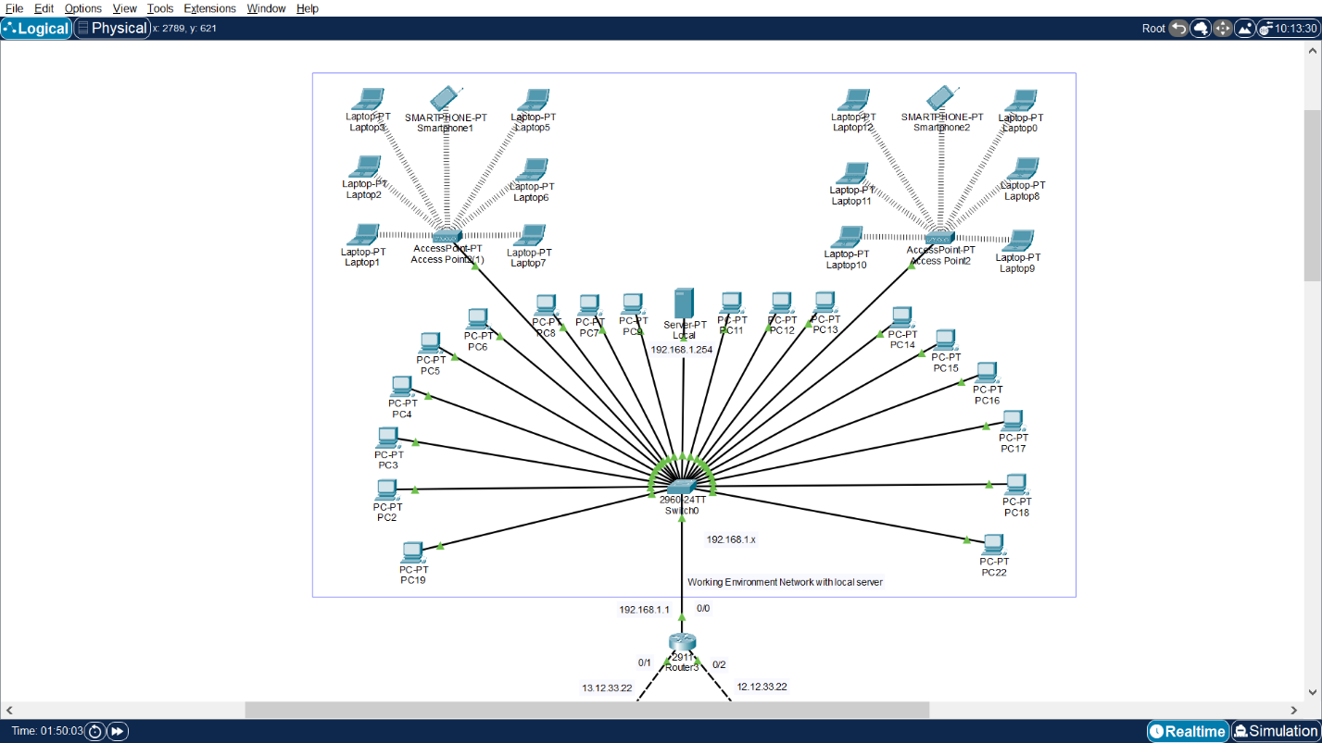

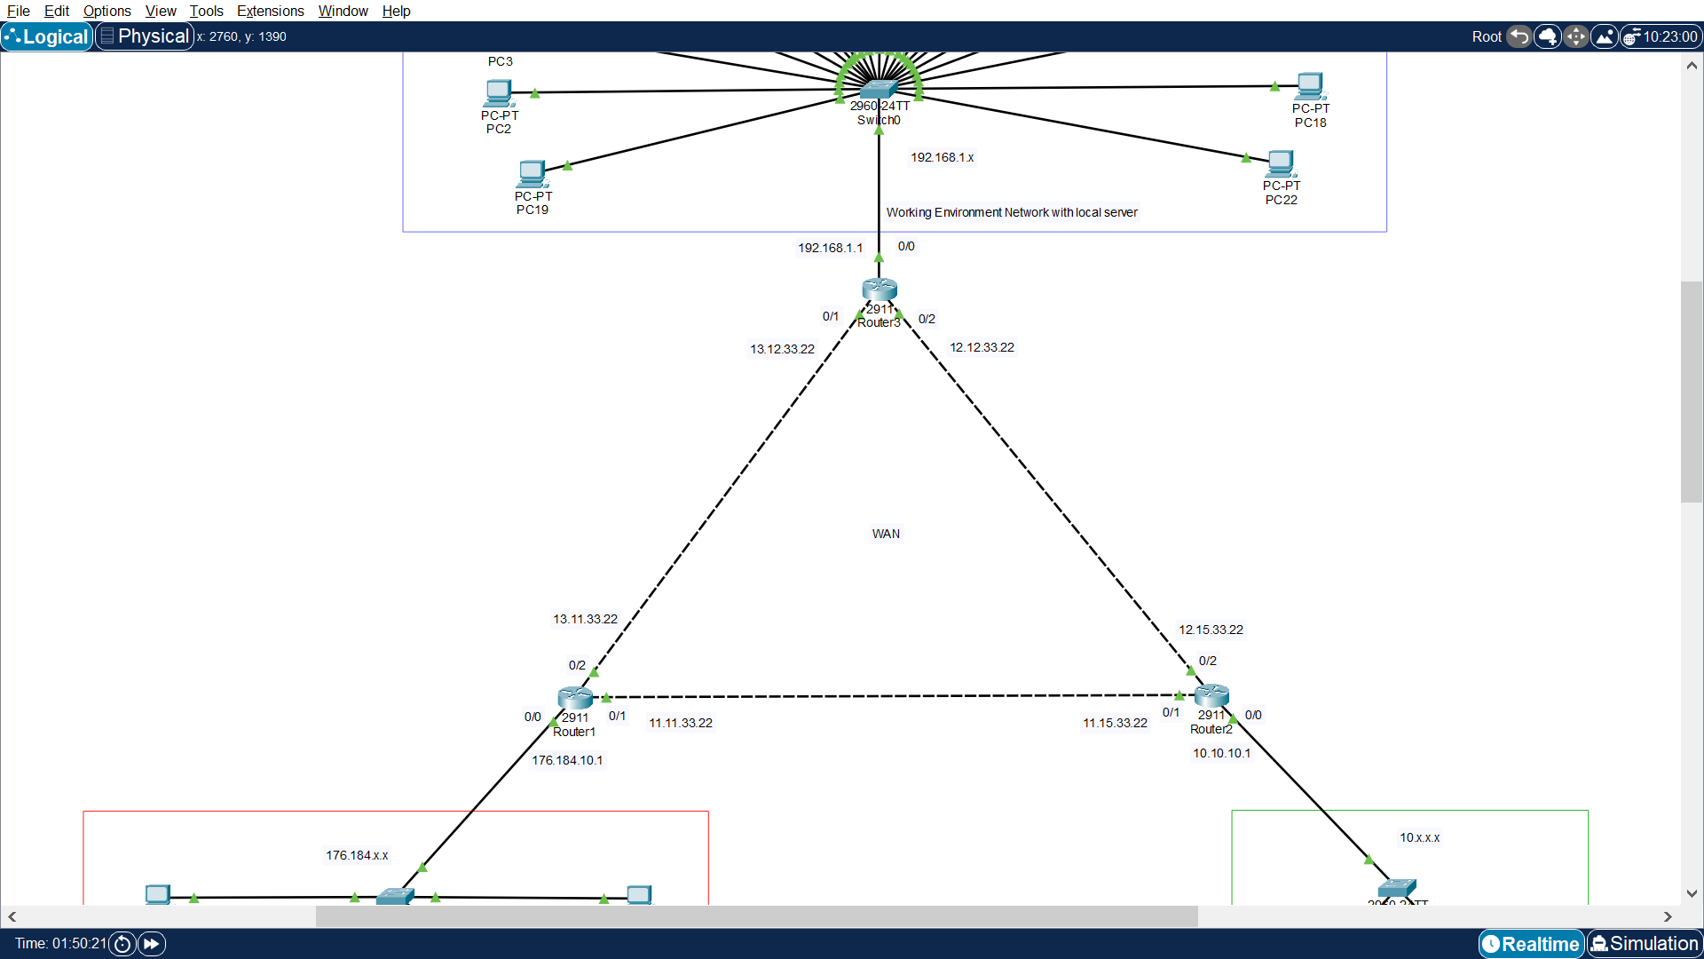

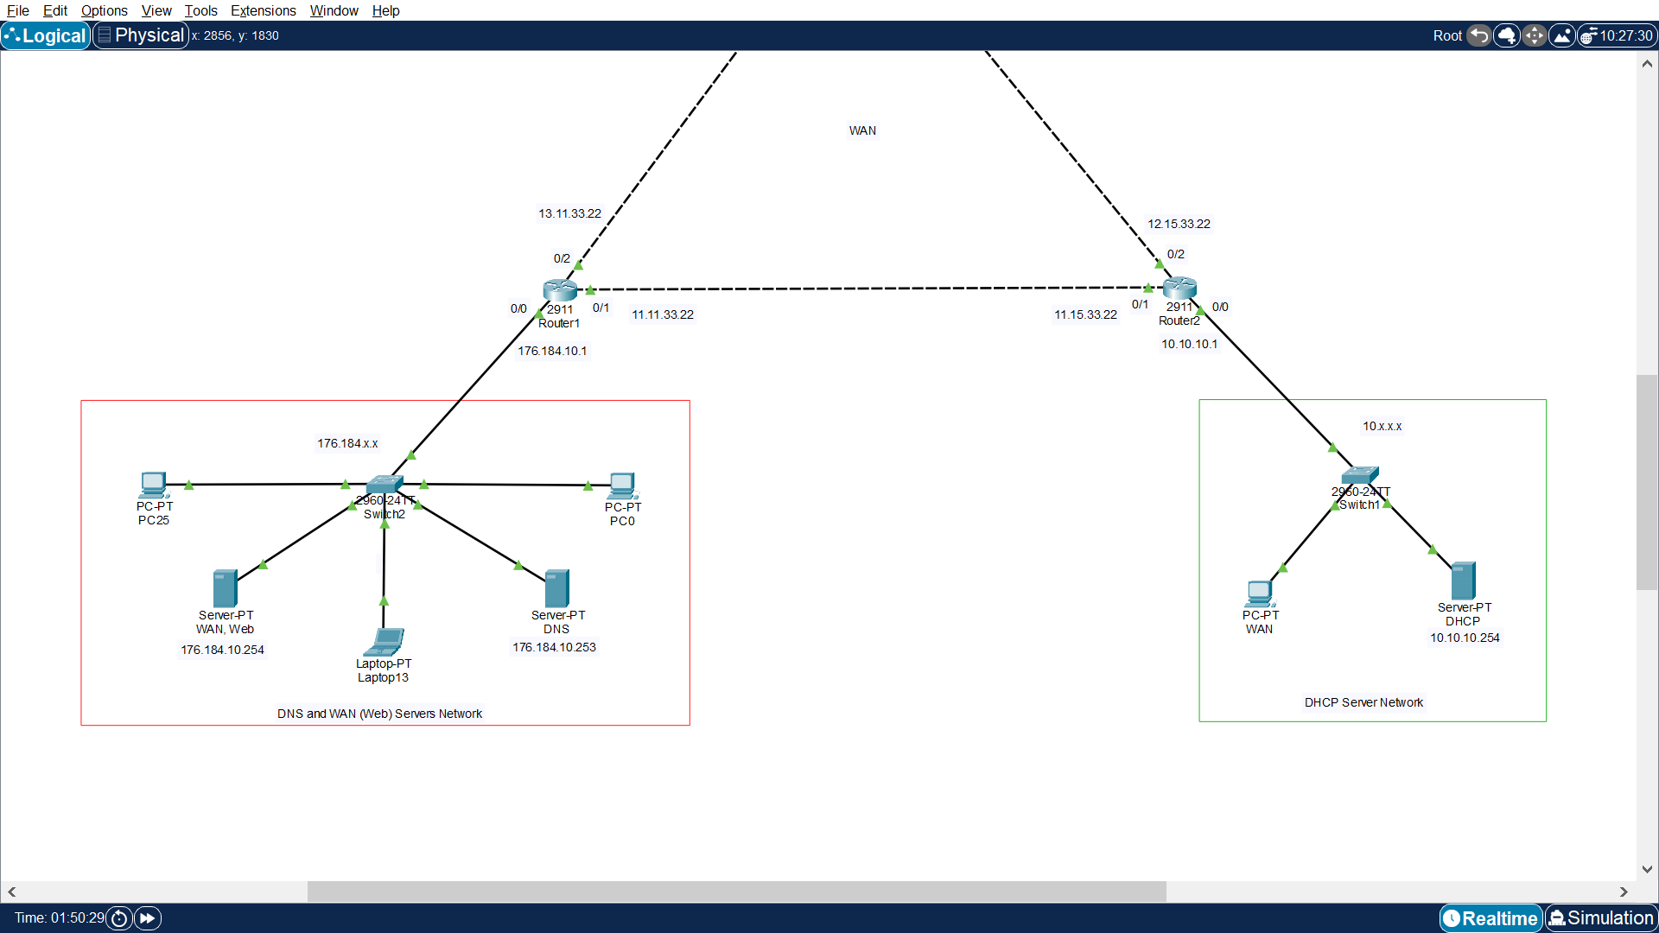

This System contains:

* 3 Routers
* 3 Switches
* 1 DHCP Server
* 1 DNS Server
* 1 WAN Web Server
* 1 Local Server
* 21 Workstation (PC)
* 2 Wireless Access Points
* 13 Laptops
* 2 Smartphones
* Copper Straight-through and Cross-over cables

I divided System into 4 Networks:

1. DNS and WAN (Web) Servers Network. It contains switch, DNS Server, WAN Web Server, 2 PCs and 1 Laptop.
2. DHCP Server Network. It contains switch DHCP Server and WAN PC.
3. Working Environment with Local Server. It contains switch, Local Server, 2 Wireless Access Points, 18 PCs, 12 Laptops and 2 Smartphones.
4. WAN Network. It is made up of 3 Routers connected to each other and configured.

To build this network I followed such order:

1. DNS and WAN (Web) Servers Network. Put Router1, connect switch to it. Connect PC and 2 Servers. Choose configuration for Network, set IP Class B. Configure WAN (Web) Server. Configure DNS Server. Connect everything to Router1 through switch. Configure router for internal Network.
2. DHCP Server Network. Put Router2, connect switch to it. Connect Server and PC to switch. Choose configuration for Network, set IP Class. Configure Server for internal network. Connect Router2 to switch and configure it. Establish connection between this router and Router1 of first Network, configure them to WAN IP class A.
3. Working Environment with Local Server. Put Router3, connect switch to it. Connect Server and PC to switch. Configure Server to be local, use IP Class C for this Network. Connect Router3 to switch and configure it. Connect this router to Router1 and Router2.
4. Establish connection and configure WAN Network between three routers.
5. Configure DHCP Server.
6. Add all rest equipment (PCs, Laptops, Smartphones), connect them, obtain IP using DHCP.
7. Test System.

**DNS and WAN (Web) Servers Network.**

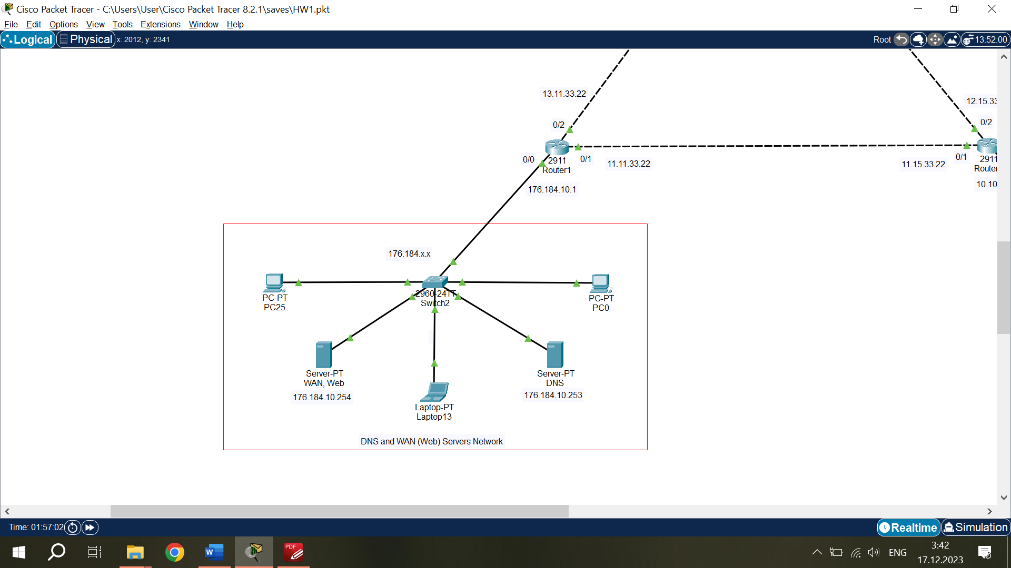

This Network has Class B IP configuration 176.184.x.x, Subnet Mask 255.255.0.0 and Default Gateway 176.184.10.1. Devices are connected to switch and switch connected to Router1 using copper straight cables.

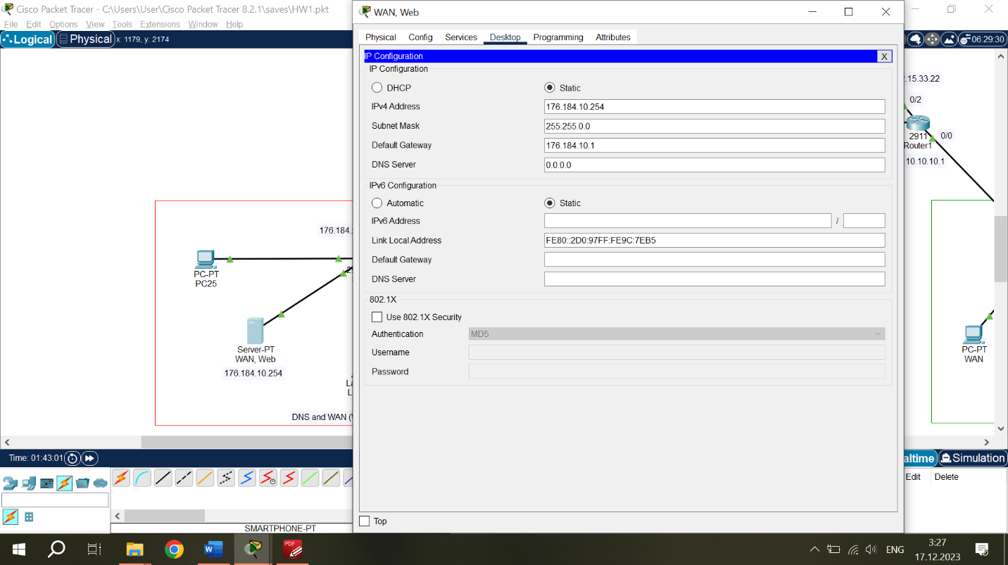*WAN (Web) Server configuration:*

IPv4 address – 176.184.10.254

Subnet Mask – 255.255.0.0

Default Gateway – 176.184.10.1

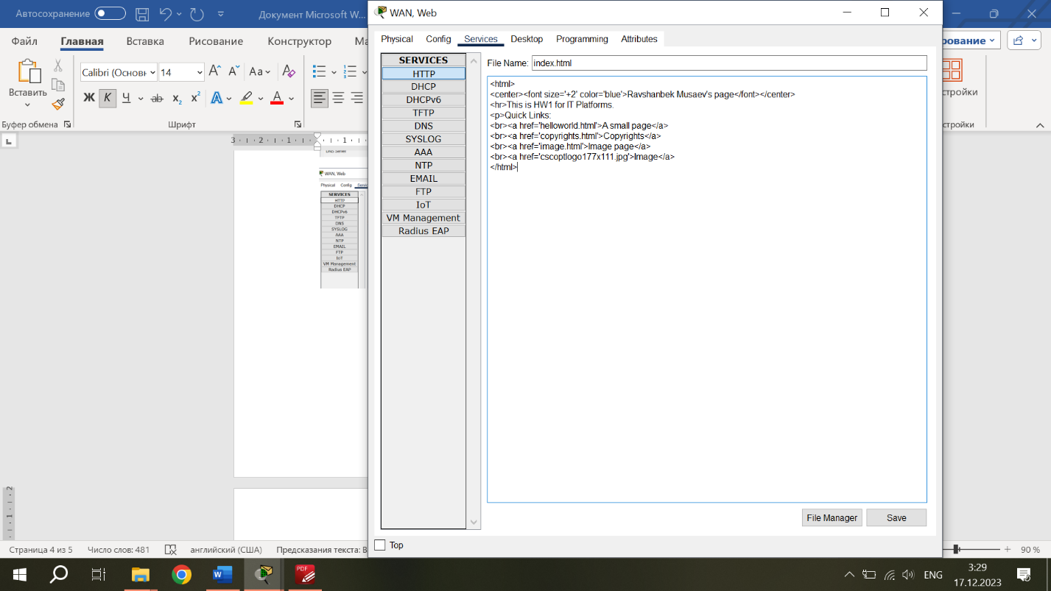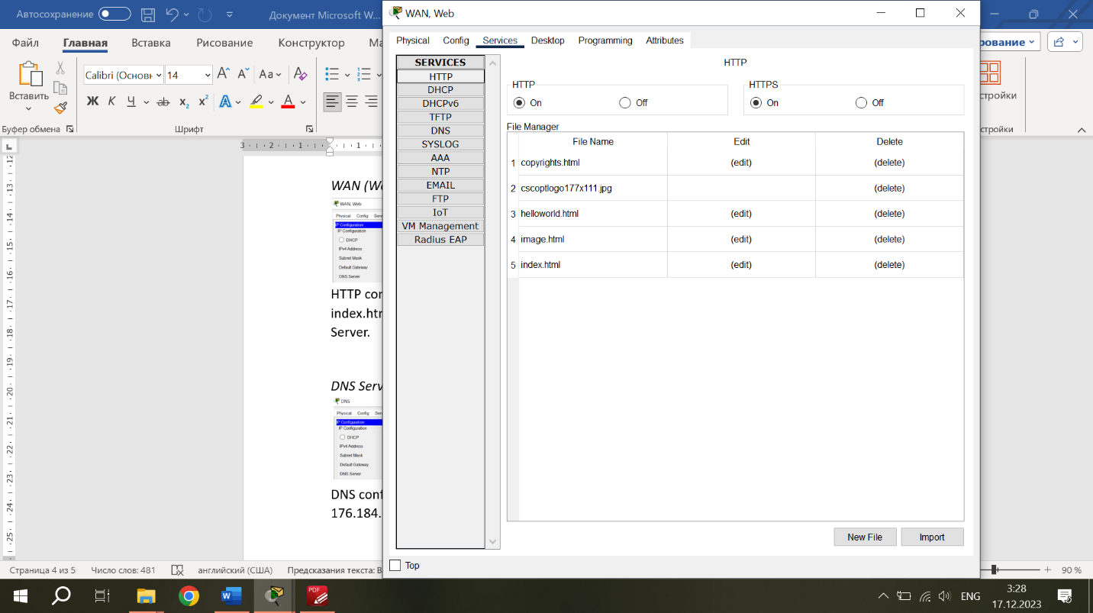

HTTP configuration enabled. Has website with IP address 176.184.10.254. I edited index.html file and customized the website. This made the server WAN (Web) Server.

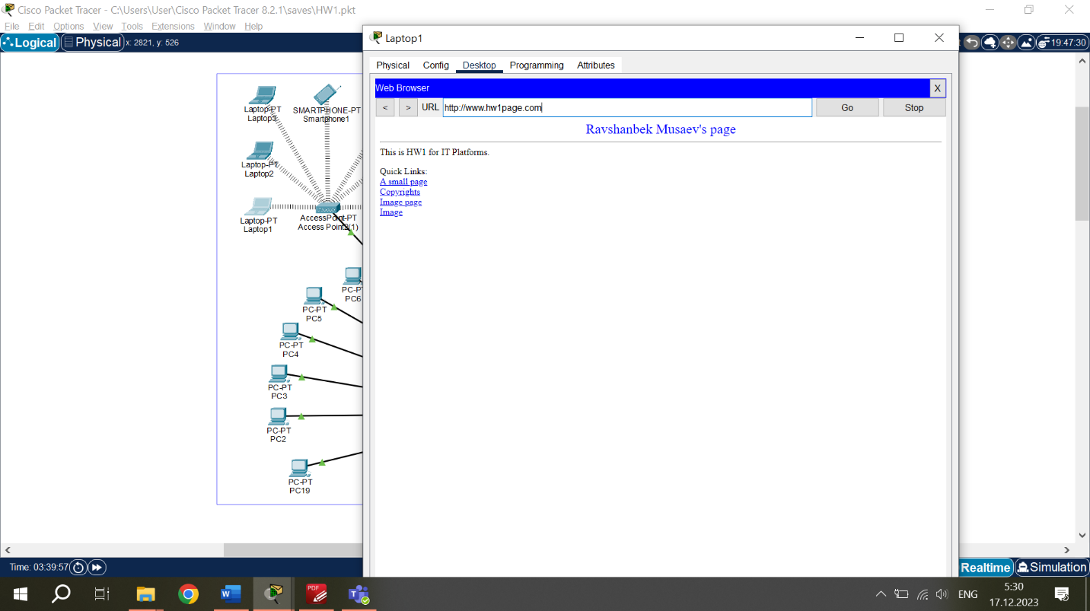The website at WAN (Web) Server.

IP Address – 176.184.10.254.

Saved as “www.hw1page.com” in DNS Server.

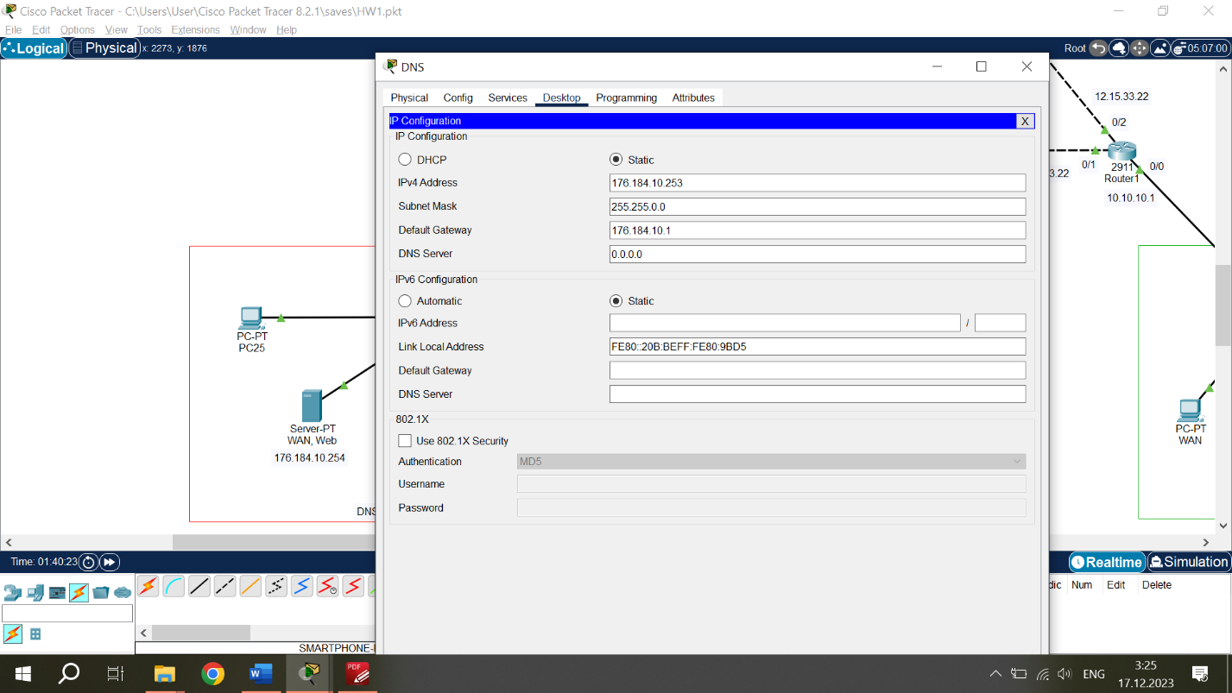*DNS Server configuration:*

IPv4 address – 176.184.10.253

Subnet Mask – 255.255.0.0

Default Gateway – 176.184.10.1

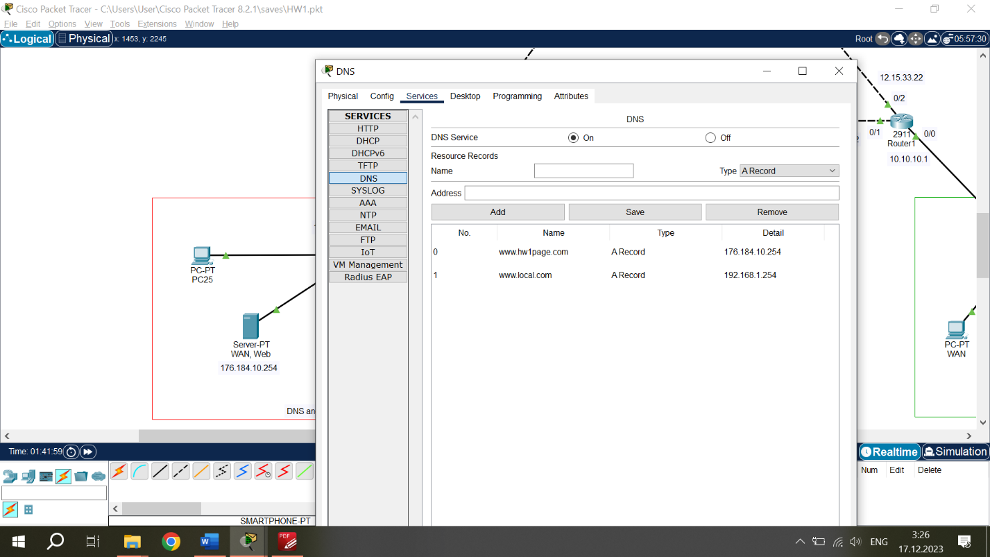DNS configuration enabled. So, IP of DNS Server for the whole System is 176.184.10.253. Then I created a record for website of WAN (Web) Server: name “www.hw1page.com” and IP address 176.184.10.254. Another record was for a website of Local Server in Workind Environment Network: name “www.local.com” and IP address 192.168.1.254. In this way DNS Server was configured.

*PCs and Laptop configuration:*

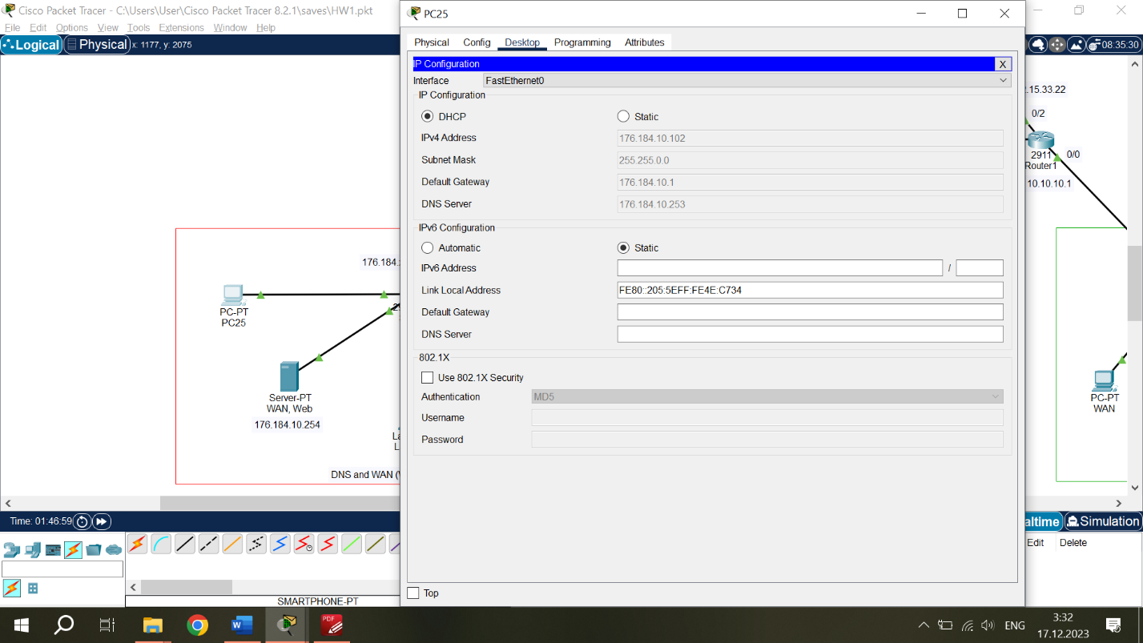

PCs and Laptop in this Network were connected to switch. IP Addresses configured automatically using DHCP, must have 176.184.10.x addresses.

**DHCP Server Network.**

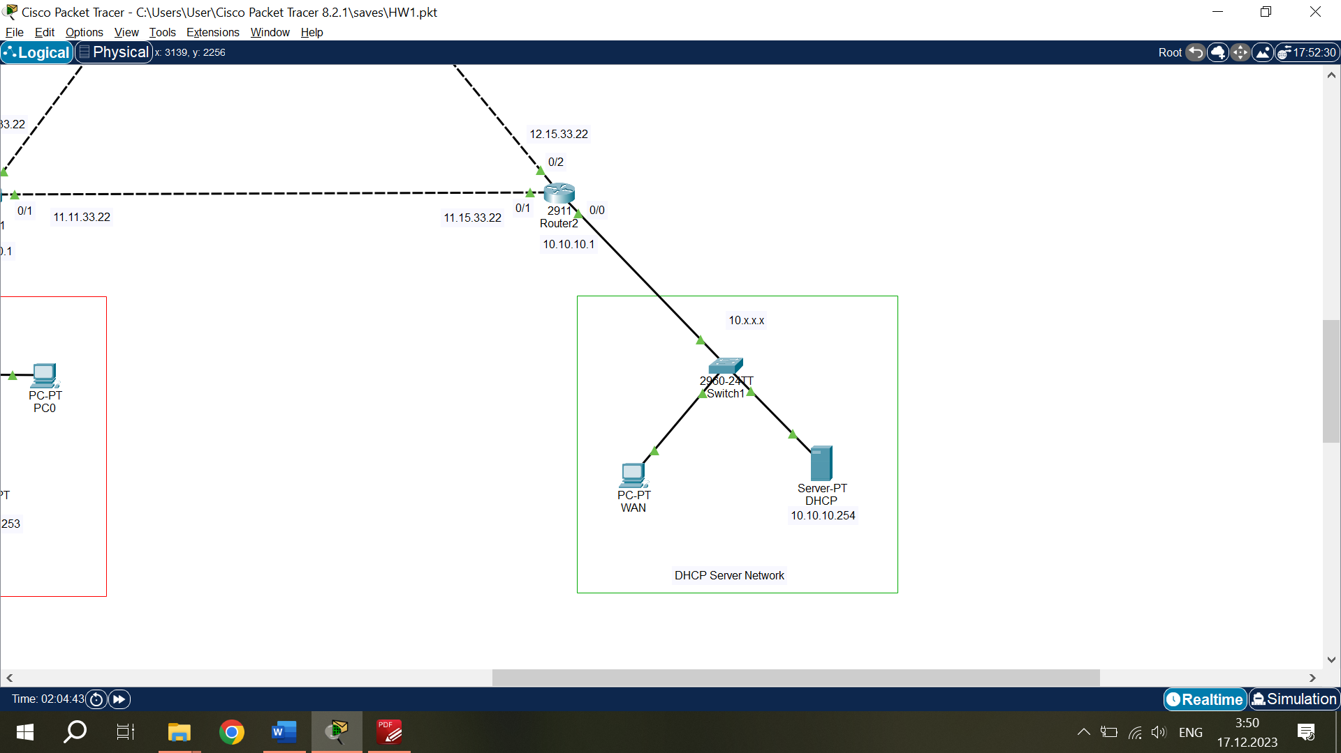

This Network has Class A IP configuration 10.x.x.x, Subnet Mask 255.0.0.0 and Default Gateway 10.10.10.1. Devices are connected to switch and switch connected to Router1 using copper straight cables.

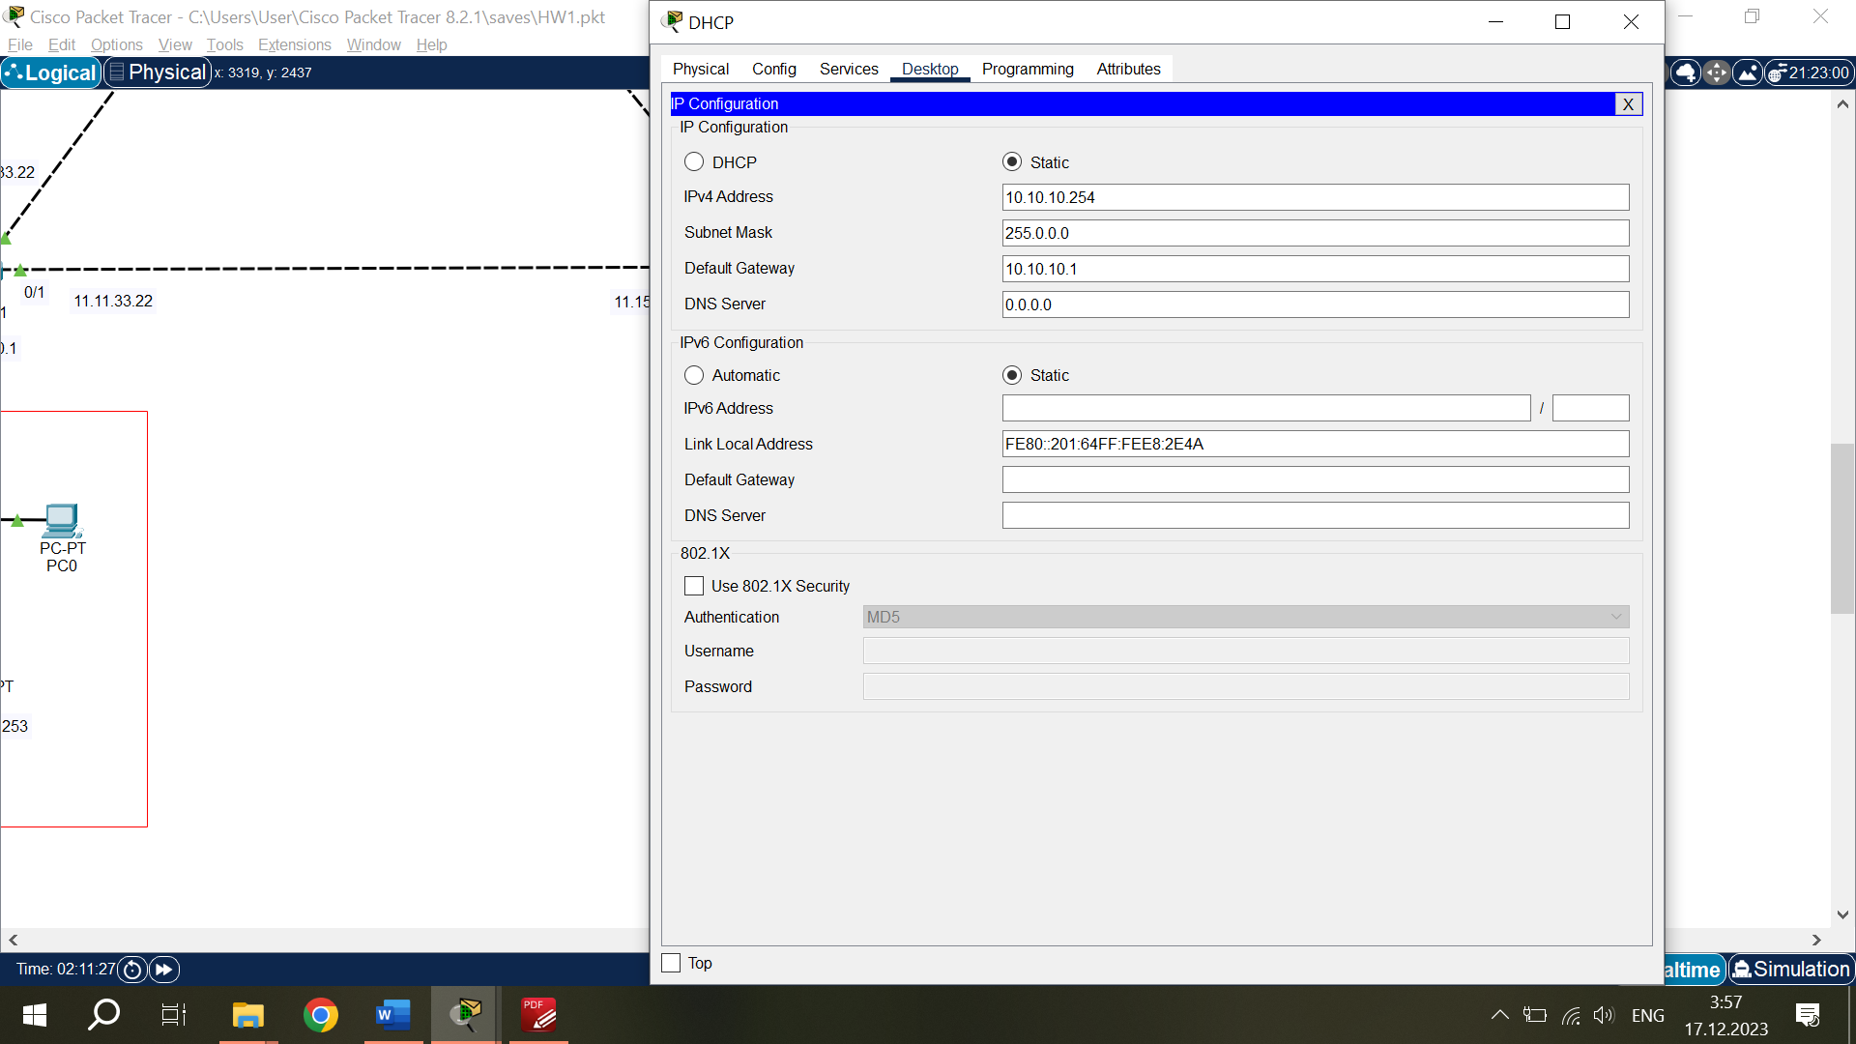*DHCP Server configuration:*

IPv4 address – 10.10.10.254

Subnet Mask – 255.0.0.0

Default Gateway – 10.10.10.1

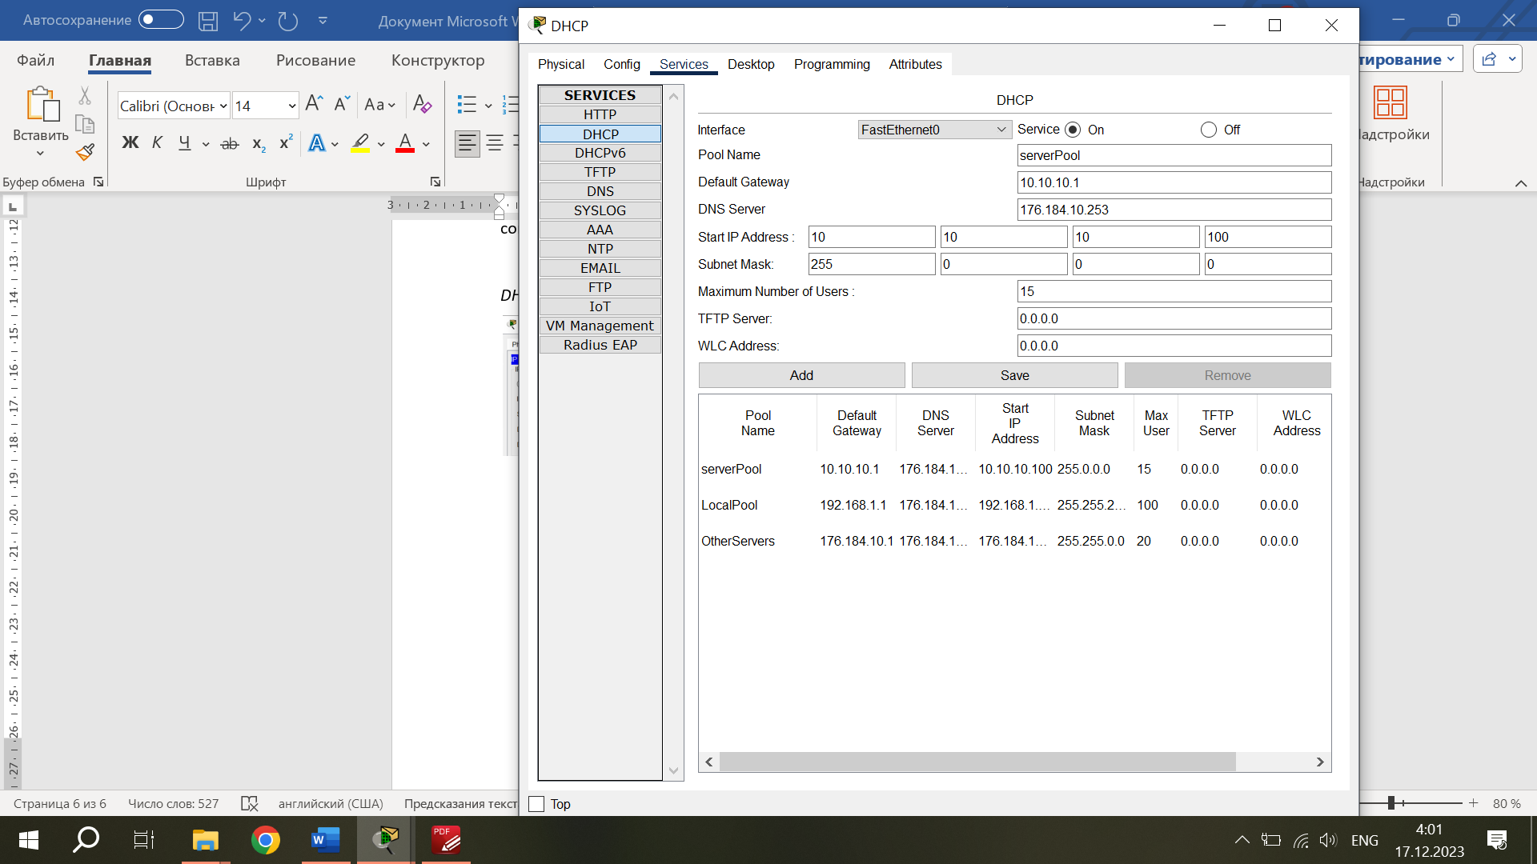

DHCP configuration enabled, and this server is DHCP Server of the System.

This DHCP Server has 3 Pools of Networks.

1. ServerPool is Pool of Network where the DHCP Server is located. Default Gateway for this Pool is 10.10.10.1, Subnet Mask 255.0.0.0 (IP Class A) and max number of users in the network is 15. DHCP Server will automatically assign IP addresses for users in Network, starting from IP 10.10.10.100 (second user will have IP 10.10.10.101, next 10.10.10.102, and so on).
2. OtherServers is Pool where WAN (Web) and DNS servers are located. Default Gateway for this Pool is 176.184.10.1, Subnet Mask 255.255.0.0 (IP Class B) and max number of users in the network is 20. DHCP Server will automatically assign IP addresses for users in Network, starting from IP 176.184.10.100.
3. Local Pool is Pool where Local Server and other devices (PC, Laptops, Smartphones) are located. Default Gateway for this Pool is 192.168.1.1, Subnet Mask 255.255.255.0 (IP Class C, local) and max number of users in the network is 100. DHCP Server will automatically assign IP addresses for users in Network, starting from IP 192.168.1.100.

As the DNS Server is working and configured, I put its IP address into the “DNS Server” field of DHCP Server for each Pool. Due to this, now all new devices when connected to any Network of the System, will be automatically provided with IP address, and connected to DNS Server. So, there is no more need to manually connect users or devices to DNS Server.

*WAN PC configuration:*

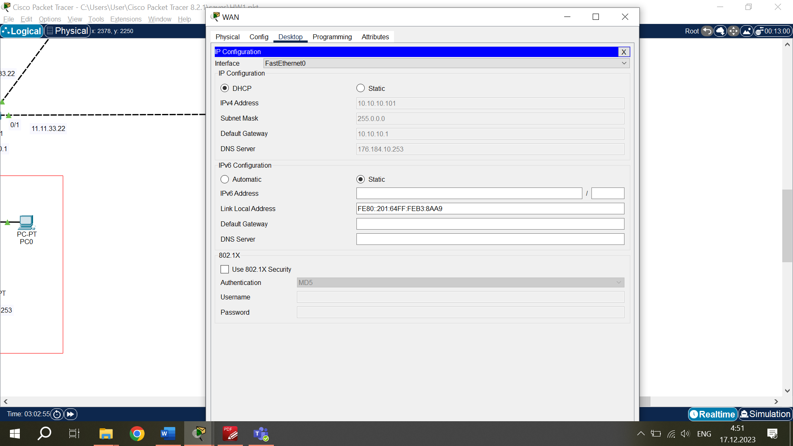IP configuration automatically assigned by DHCP.

IPv4 address – 10.10.10.101

Subnet Mask – 255.0.0.0

Default Gateway – 10.10.10.1

DNS Server – 176.184.10.253

This PC is considered WAN, because it is in the IP Class A Network with Subnet Mask 255.0.0.0.

**Working Environment with Local Server Network.**

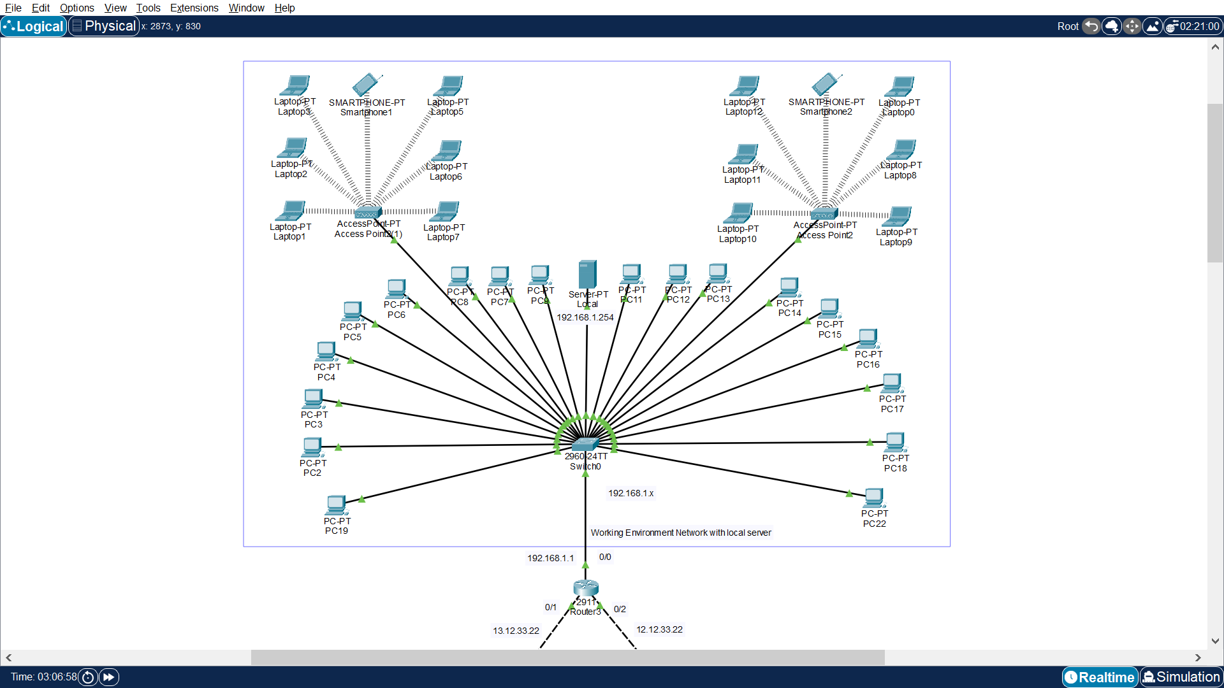

This Network has Class C IP configuration 192.168.10.x, Subnet Mask 255.0.0.0 and Default Gateway 10.10.10.1. It is a local Network. PCs and Local Server are connected directly to switch. Also 2 Wireless Access Points are connected to switch. Laptops and Smartphones are connected Wirelessly to Access Points. Switch connected to Router3 using copper straight cables.

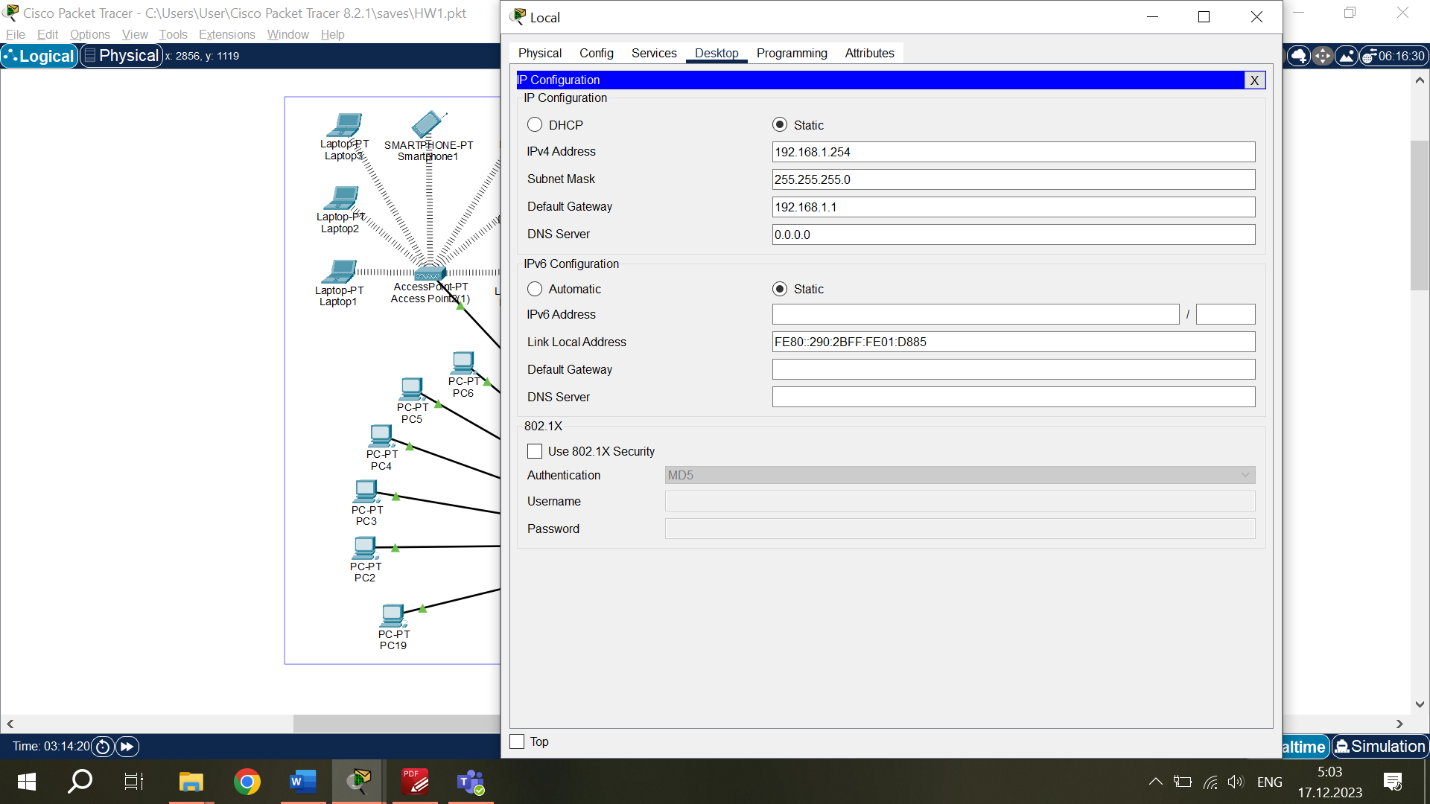*Local Server configuration:*

IPv4 address – 192.168.1.254

Subnet Mask – 255.255.255.0

Default Gateway – 192.168.1.1

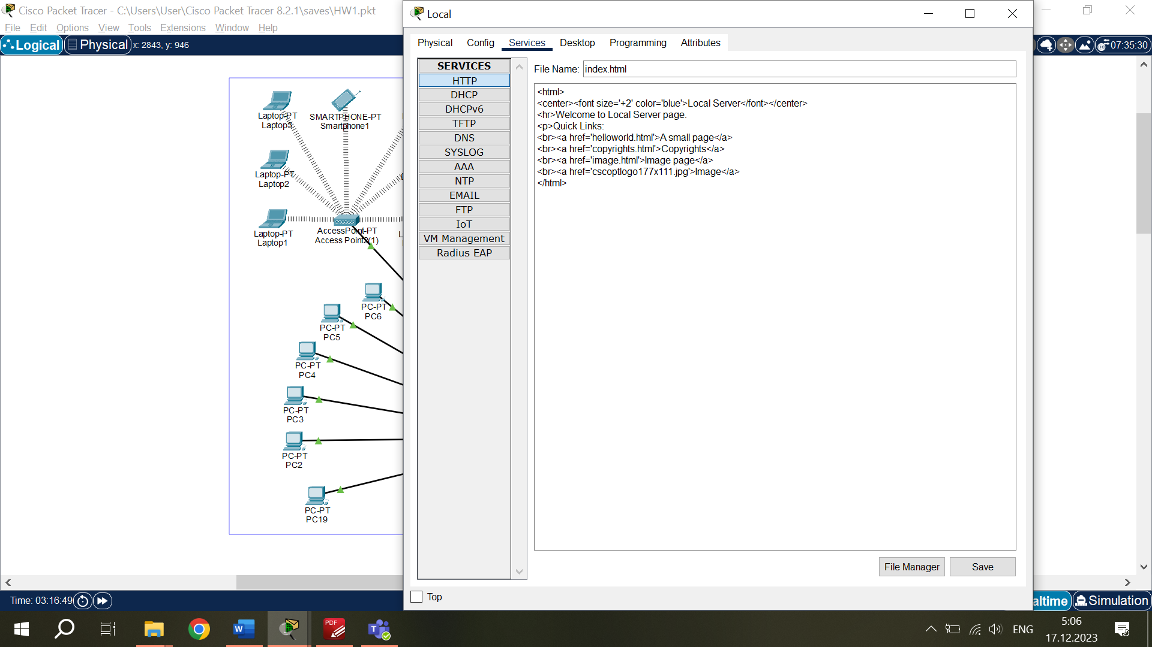This Server is local, it can be seen from Subnet Mask – 255.255.255.0, which is IP Class C.

I configured HTTP service for it and created Website with IP address 192.168.1.254.

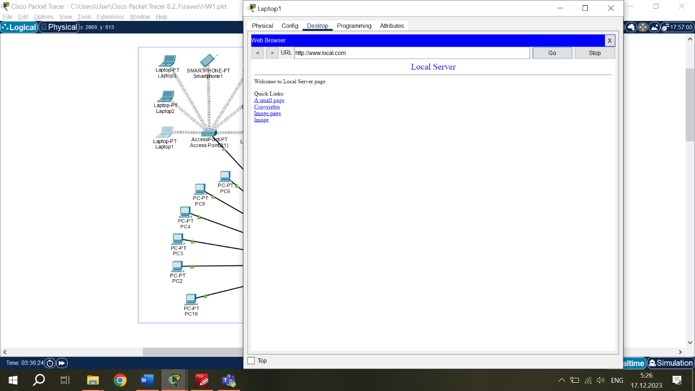The website at Local Server.

IP Address – 192.168.1.254.

Saved as “www.local.com” in DNS Server.

*PCs configuration:*

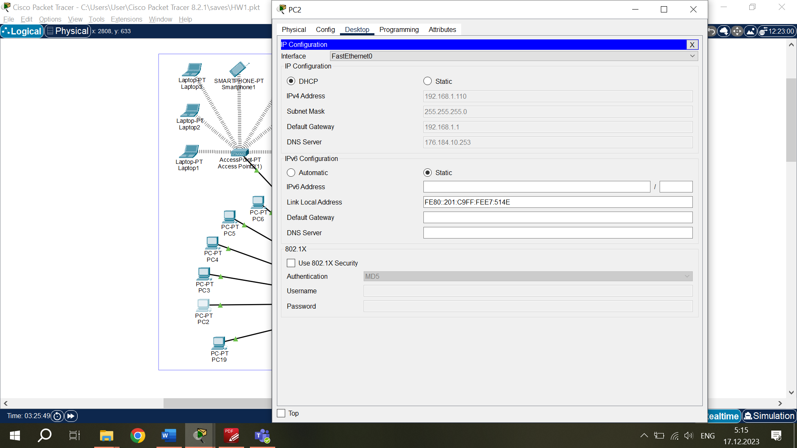IP configuration to each device is automatically assigned by DHCP.

IPv4 address – starting 192.168.1.100

Subnet Mask – 255.255.255.0

Default Gateway – 192.168.1.1

DNS Server – 176.184.10.253

All PCs are connected with straight copper cables to switch.

*Laptops configuration:*

All Laptops in this Network are connected to Wireless Access Points. To make it possible it is necessary to install the wireless interface module to each laptop. After installing the module, laptops will automatically connect to the nearest Wireless Access Point.

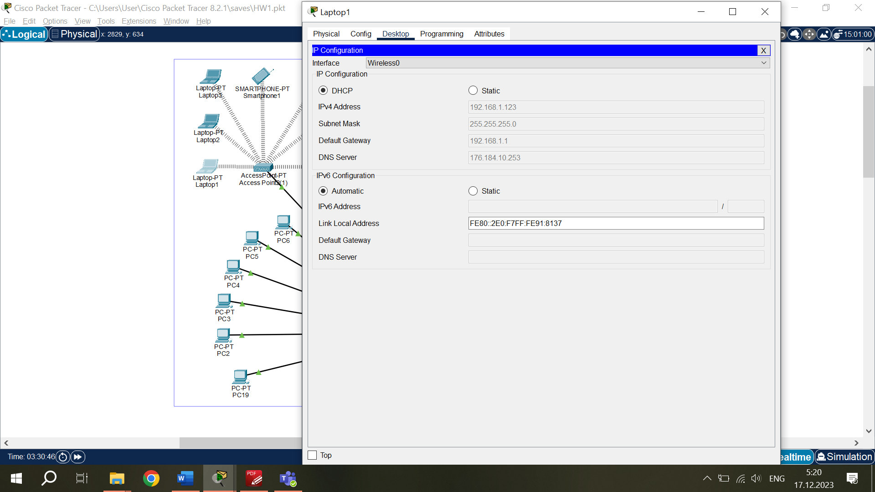IP configuration to each device is automatically assigned by DHCP.

IPv4 address – starting 192.168.1.100

Subnet Mask – 255.255.255.0

Default Gateway – 192.168.1.1

DNS Server – 176.184.10.253

*Smartphones configuration:*

Smartphones automatically connect to the nearest Wireless Access Point.

IP configuration to each device is automatically assigned by DHCP.

IPv4 address – starting 192.168.1.100. Subnet Mask – 255.255.255.0

Default Gateway – 192.168.1.1. DNS Server – 176.184.10.253

**WAN Network.**

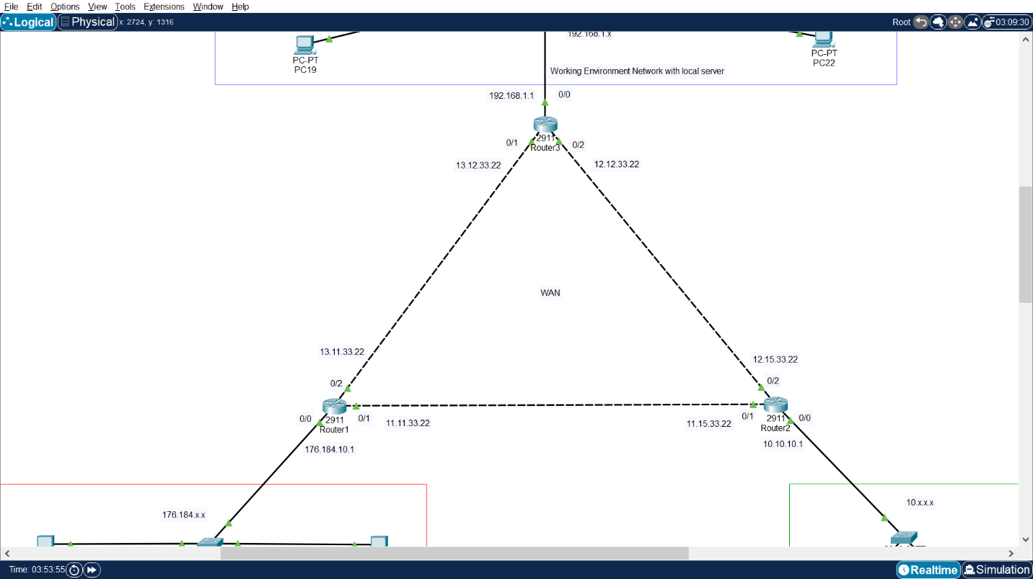

WAN Network consists of 3 Routers which are connected to each other with cross-over copper cables. Router1 is connected to Router2 and Router3; Router2 is connected to Router1 and Router3; and Router3 is connected to Router1 and Router2. This system, when configured, creates a WAN Network connecting all 3 Networks with their devices and Servers.

*Router1 configuration:*

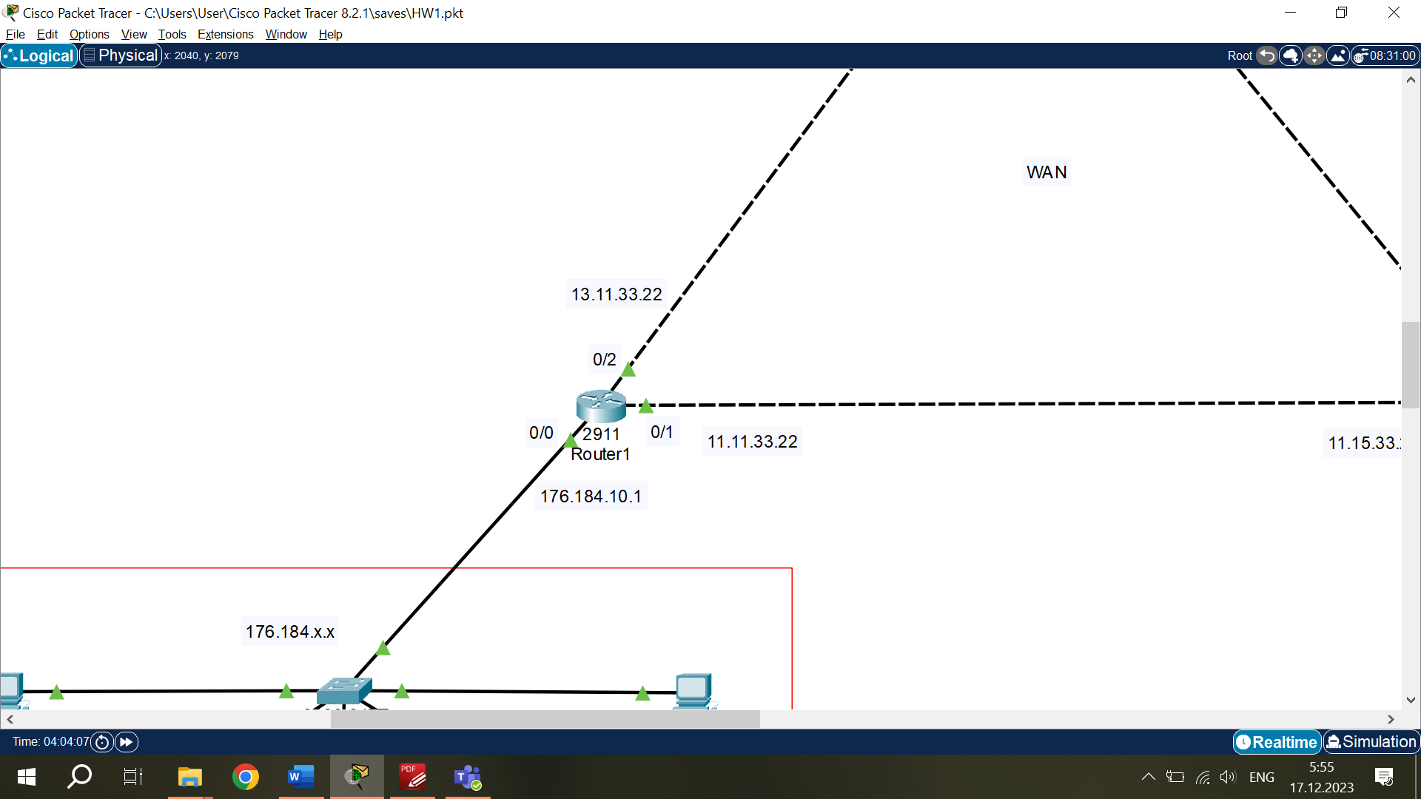

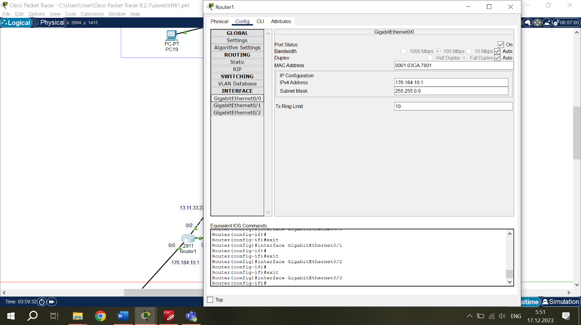

Router’s configurations page.

Port GigabitEthernet 0/0 is connected to switch of DNS and WAN (Web) Servers Network. It is IP Class B Network. IP Address of its Gateway is 176.184.10.1 and Subnet Mask – 255.255.0.0.

Port GigabitEthernet 0/1 is connected to Router2. It is already WAN Network and is IP Class A. IP Address of its Gateway is 11.11.33.22 and Subnet Mask –255.0.0.0.

Port GigabitEthernet 0/2 is connected to Router2. WAN Network, IP Class A, address 13.11.33.22 and Subnet Mask – 255.0.0.0.

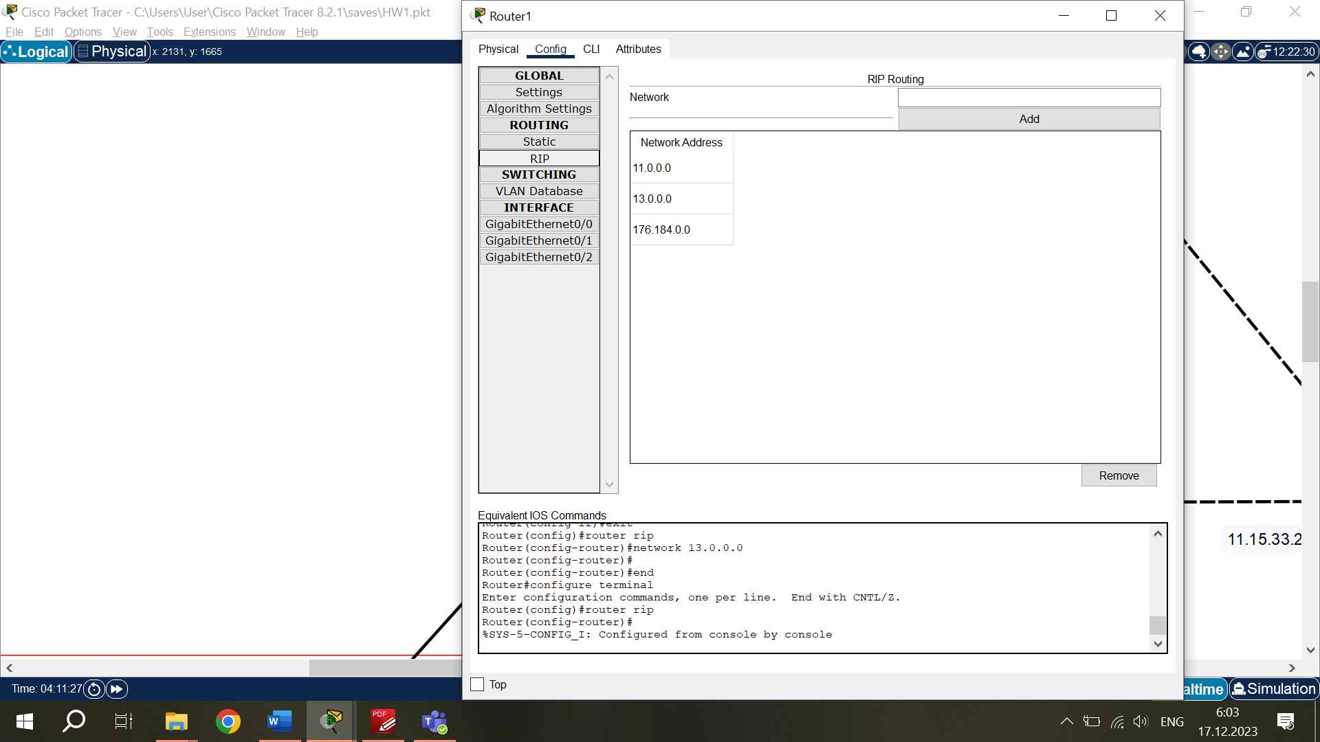To make the connection between routers work properly, it is necessary to configure RIP Routing. I added Network Addresses of each Network which is connected to Router1. To add the address, I typed the Default Gateway of Network, but only those digits which correspond to “255” in the Subnet Mask. All other digits must be “0”, it means that all IPs of Network are included in RIP Routing.

*Router2 configuration:*

Port GigabitEthernet 0/0 is connected to switch of DHCP Server Network, IP Class A, address 10.10.10.1 and Subnet Mask – 255.0.0.0.

Port GigabitEthernet 0/1 is connected to Router1. WAN Network, IP Class A, address 11.15.33.22 and Subnet Mask – 255.0.0.0.

Port GigabitEthernet 0/2 is connected to Router3. WAN Network, IP Class A, address 12.15.33.22 and Subnet Mask – 255.0.0.0.

RIP Routing – 10.0.0.0, 11.0.0.0, 12.0.0.0.

*Router3 configuration:*

Port GigabitEthernet 0/0 is connected to switch of Working Environment Network, local network, IP Class C, address 192.168.1.1 and Subnet Mask – 255.255.255.0.

Port GigabitEthernet 0/1 is connected to Router1. WAN Network, IP Class A, address 13.12.33.22 and Subnet Mask – 255.0.0.0.

Port GigabitEthernet 0/2 is connected to Router2. WAN Network, IP Class A, address 12.12.33.22 and Subnet Mask – 255.0.0.0.

RIP Routing – 192.168.1.0, 12.0.0.0, 13.0.0.0.

*DHCP configuration in Routers.*

To connect Networks to DHCP Server and make it possible for devices to automatically obtain IP and DNS addresses from DHCP Server, it is necessary to configure Routers. Configuration takes place in CLI of Router.

These commands must be written in same order:

*exit*

*exit*

*enable*

*configure terminal*

*int GigabitEthernet 0/0*

*ip helper-address 10.10.10.254*

*exit*

*exit*

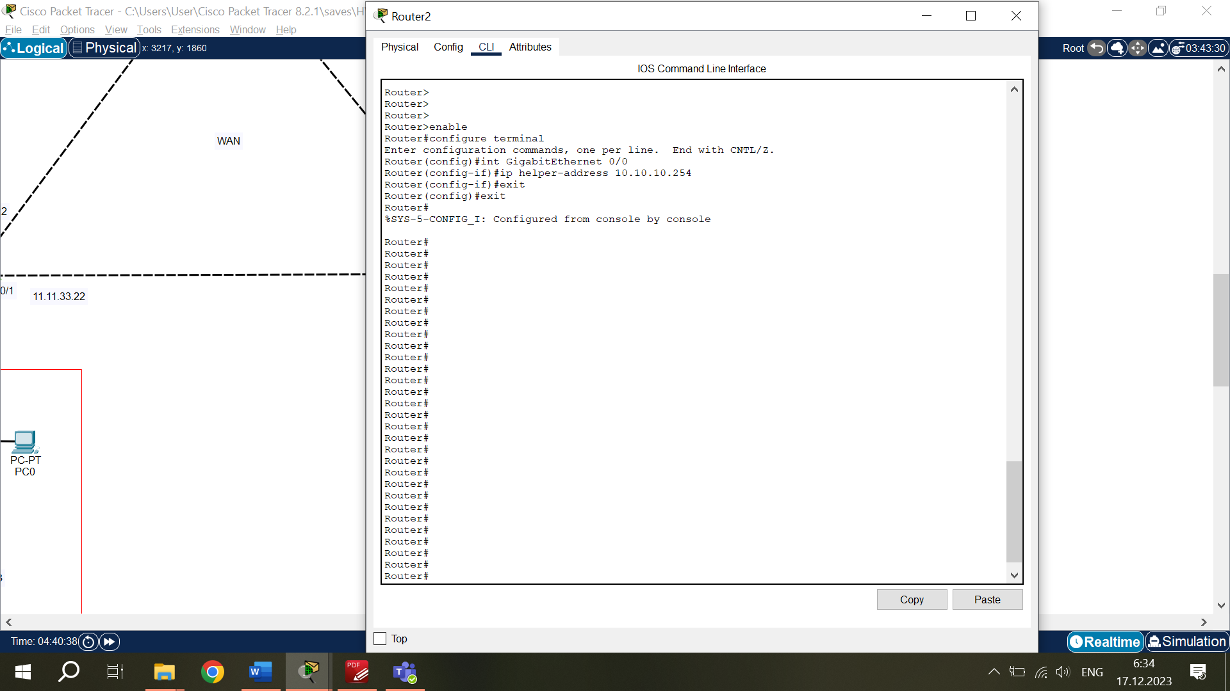I used Port GigabitEthernet 0/0 to connect Router to its Network, not another Router. And I have only one DHCP Server, so I have to connect all Networks to it. That’s why for each Router this CLI configuration will be the same.

Now all System is configured and must be working properly.

**Testing the System.**

*DHCP test.*

To check if the System is connected and if DHCP Server is configured correctly, I will reset the IP with DHCP function on several devices from different Networks.

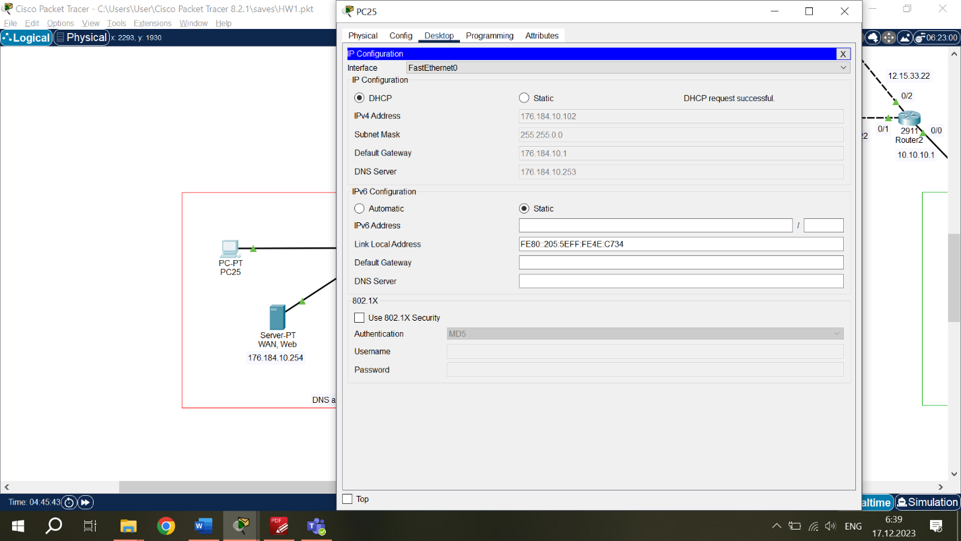

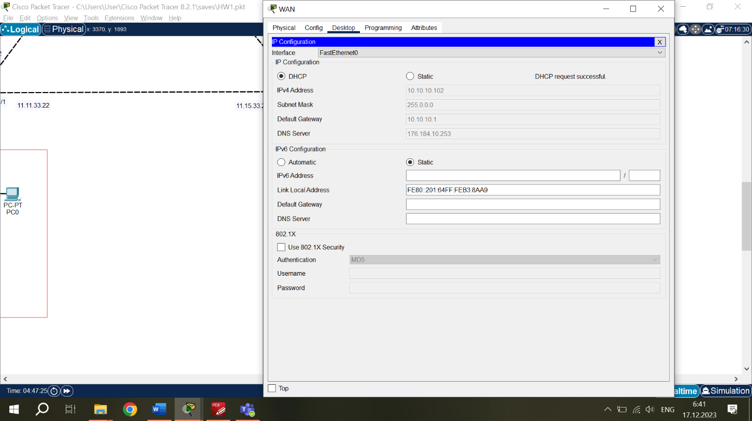PC from WAN and DNS Servers Network. DHCP works correctly.

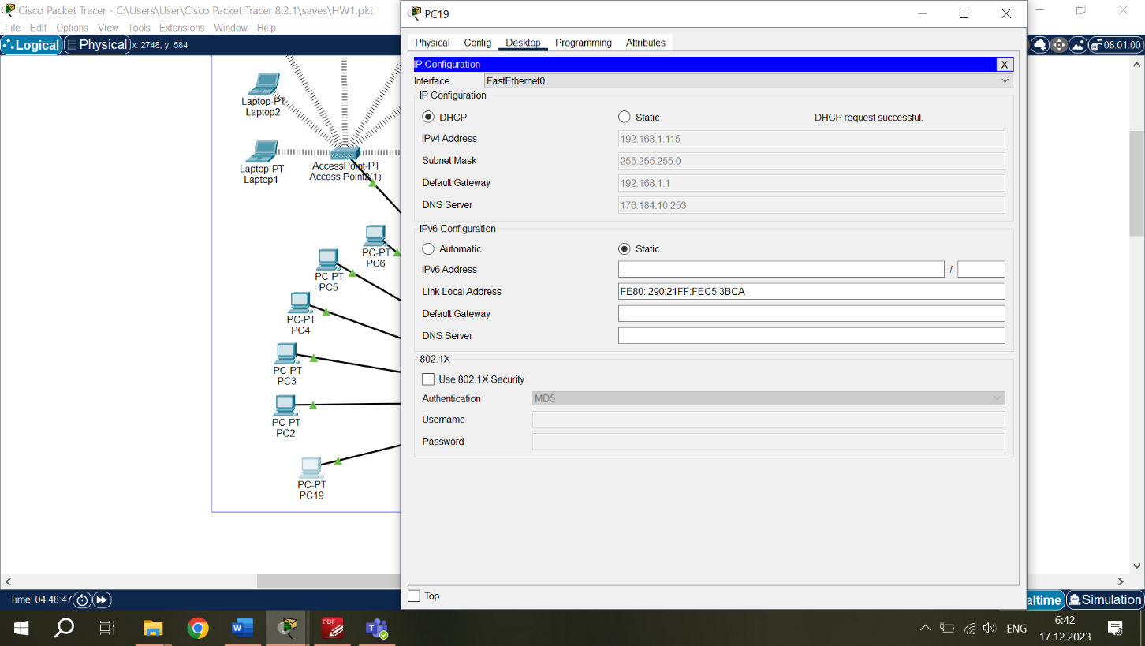WAN PC from DHCP Server Network. DHCP works correctly.

PC from Working Environment Network. DHCP works correctly.

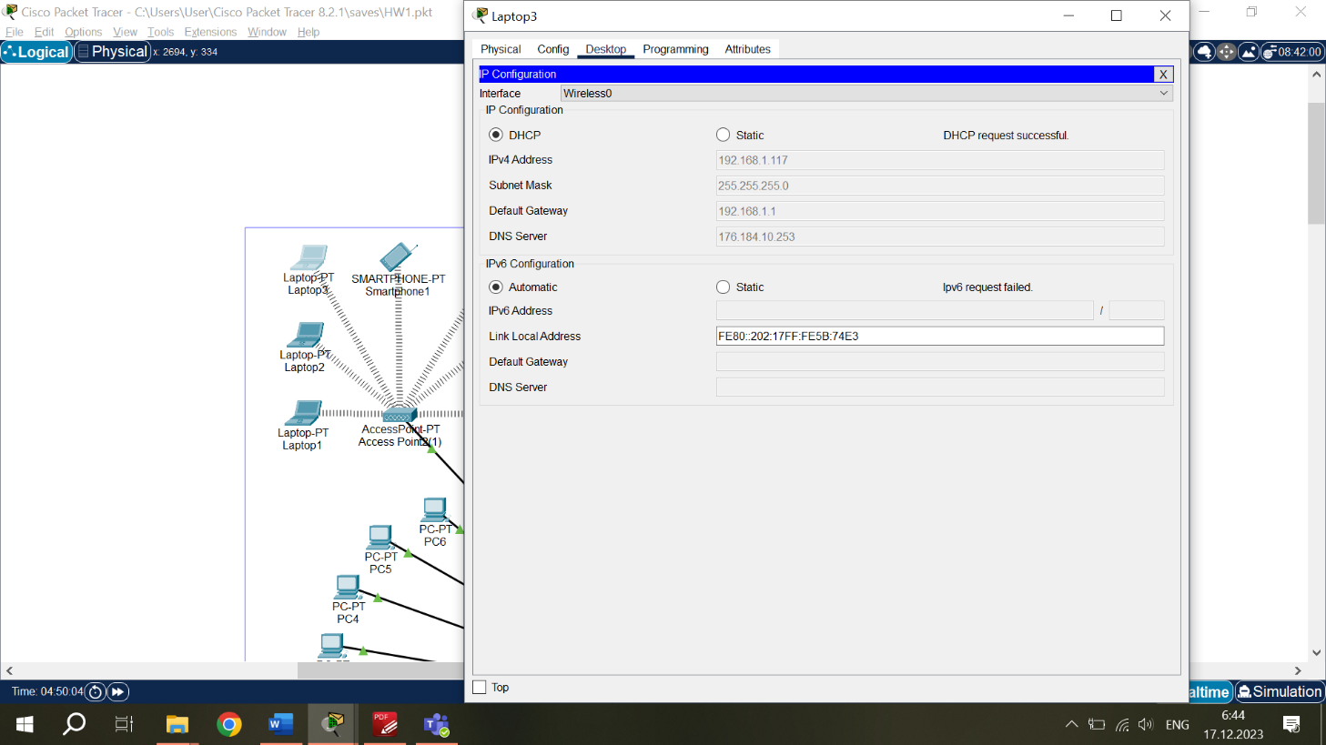

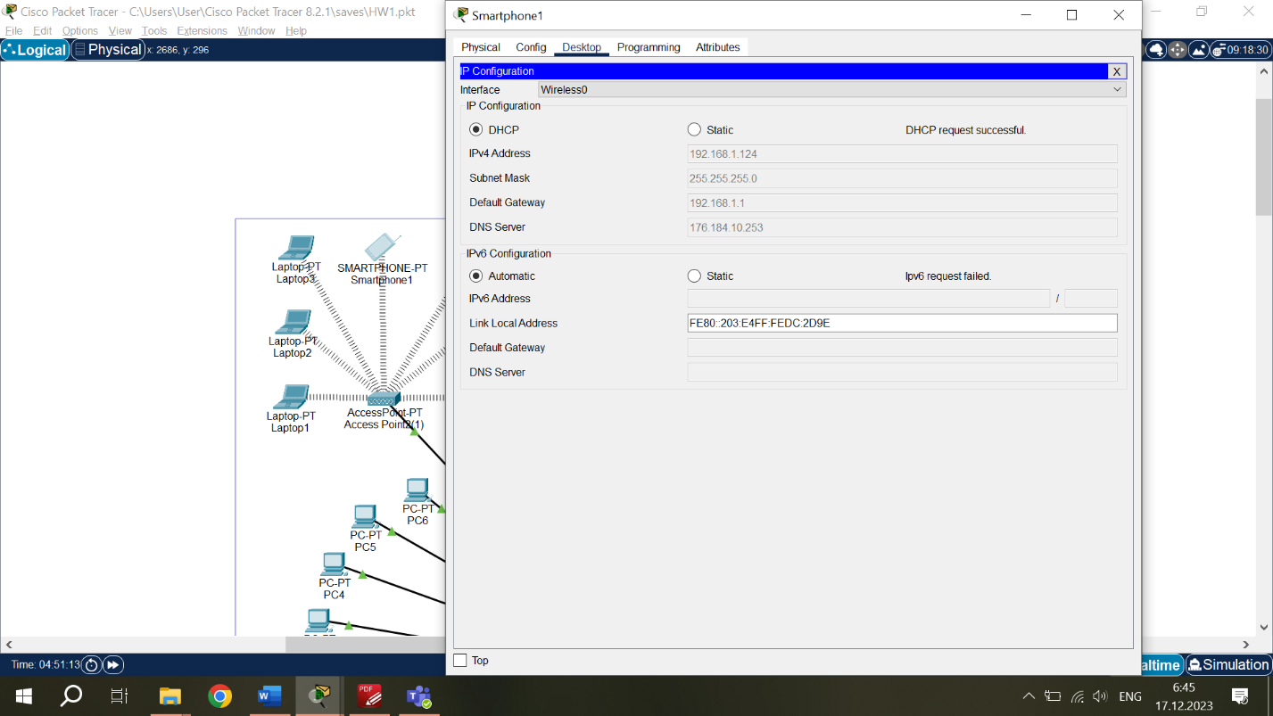Laptop from Working Environment Network. DHCP works correctly.

Smartphone from Working Environment Network. DHCP works correctly.

DHCP works correctly.

*DNS Test.*

To check if the DNS Server works, I will try to open my websites from any device. And particularly, in Web browser, I should type not the IP address of Website, but its “name”.



With the request “www.hw1page.com” I was able to open my Website which is on WAN (Web) Server.



With the request “www.local.com” I was able to open my Website which is on Local Server.

DNS works correctly.

*Ping Test.*

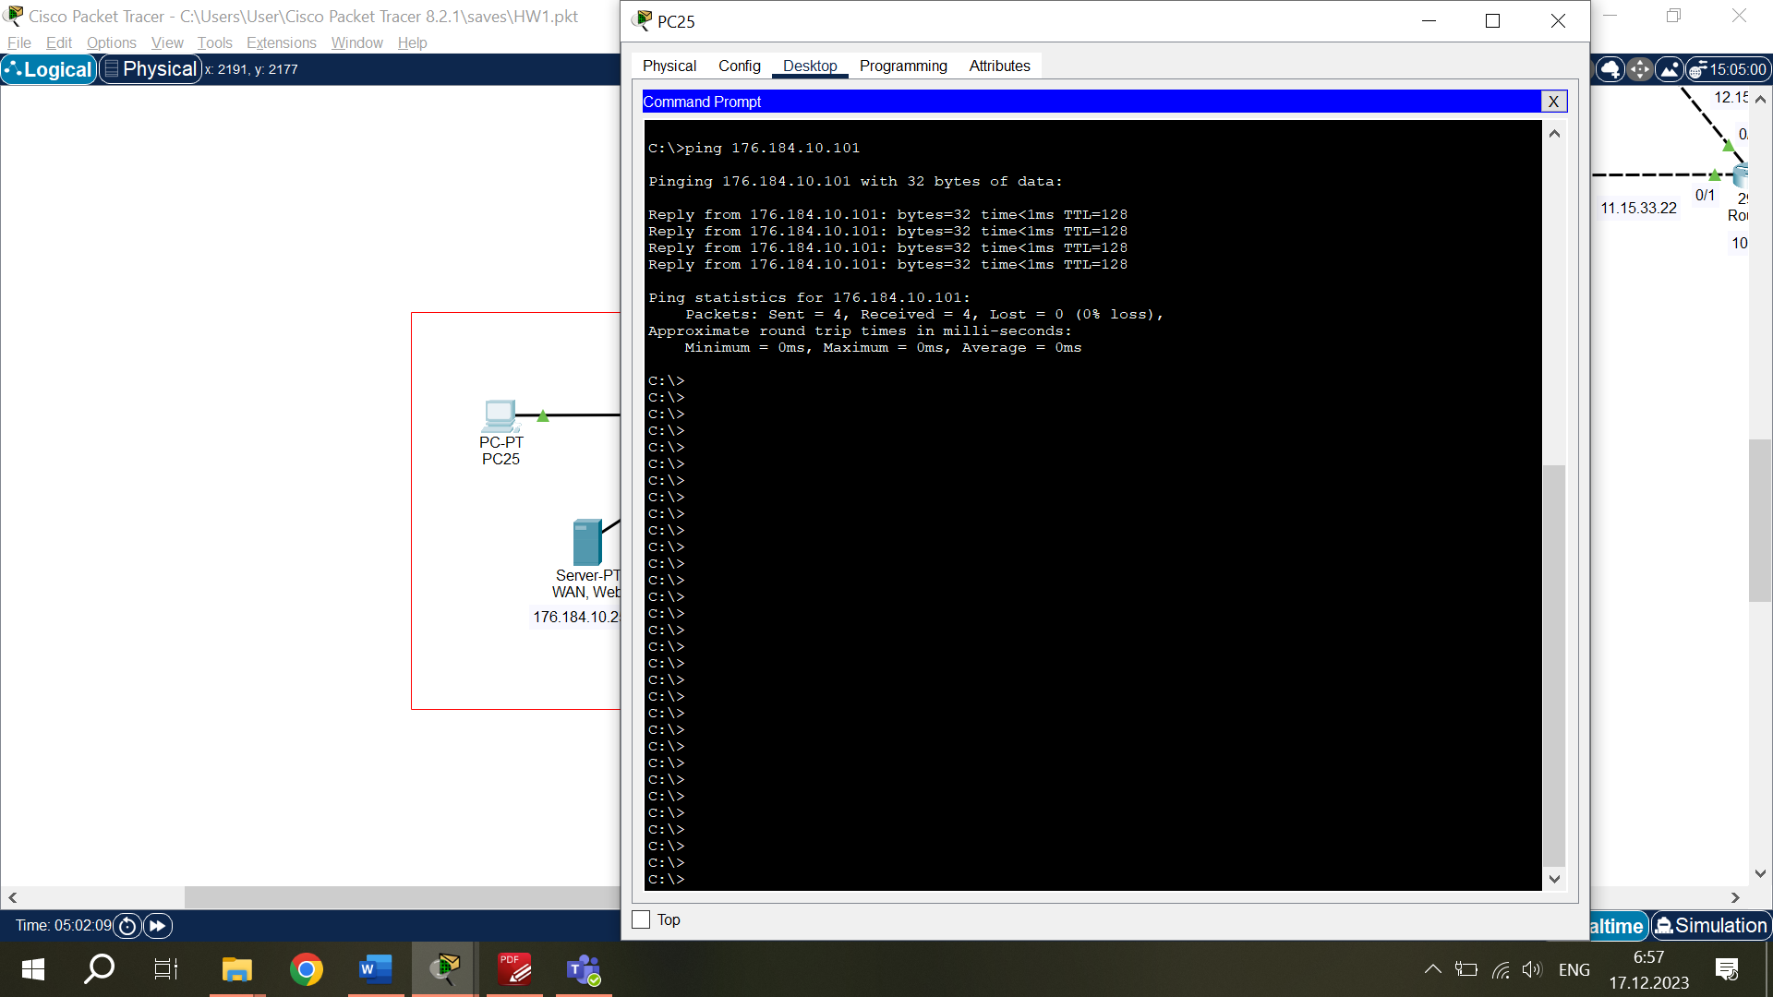To check the connection between various parts of the System, I will ping devices inside Network and from device in one Network to device in another Network.

Successful Ping Test inside WAN (Web) and DNS Servers Network. Ping from PC 176.184.10.102 to PC 176.184.10.101.

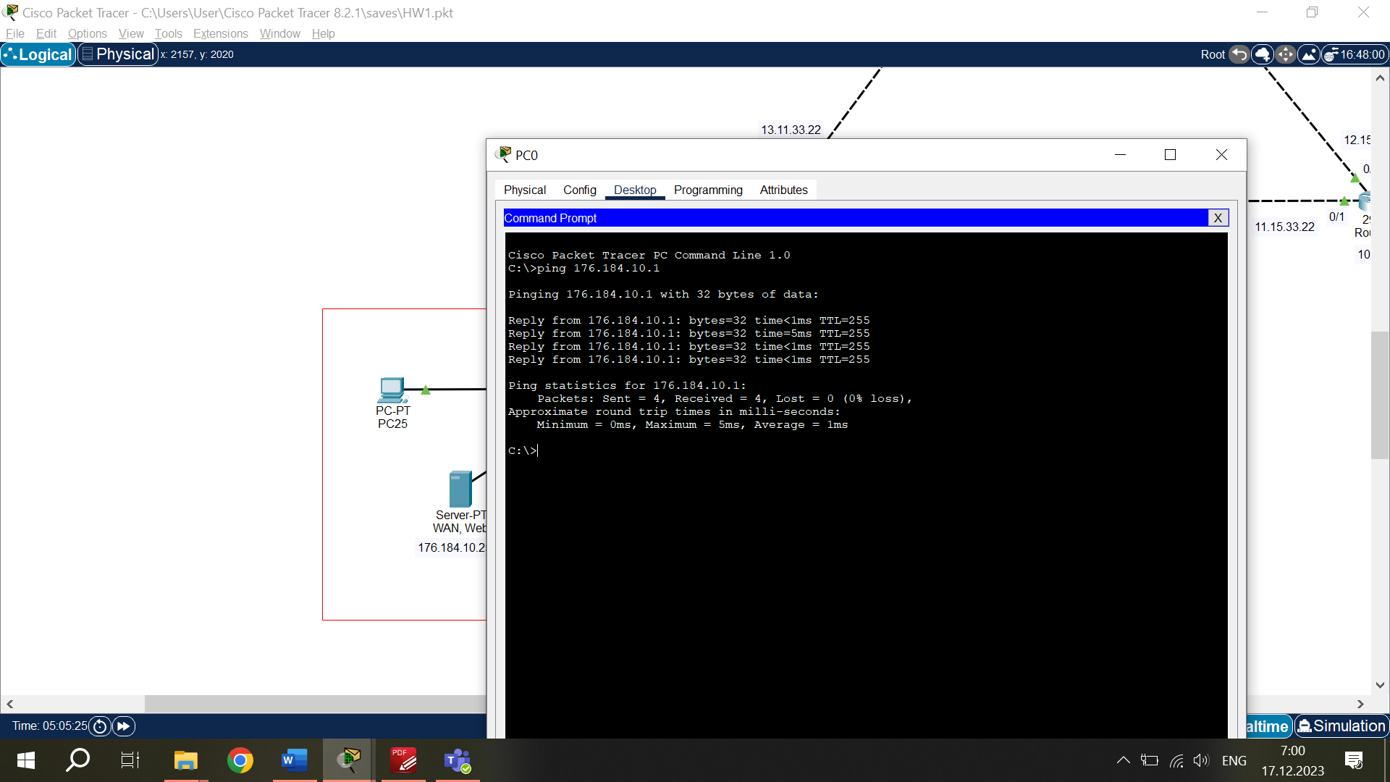

Successful Ping Test from PC in WAN (Web) and DNS Servers Network to Router1. Ping from PC 176.184.10.102 to Router1 176.184.10.1.

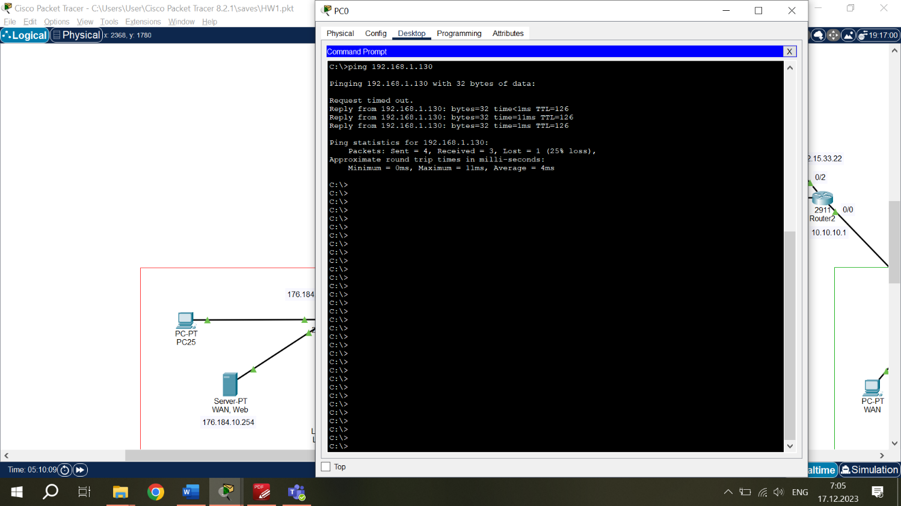Successful Ping Test from PC in WAN (Web) and DNS Servers Network to Laptop in Working Environment Network. Thus, Router 3 and Wireless Access Points are also working properly. Ping from PC 176.184.10.102 to Laptop 192.168.1.130.

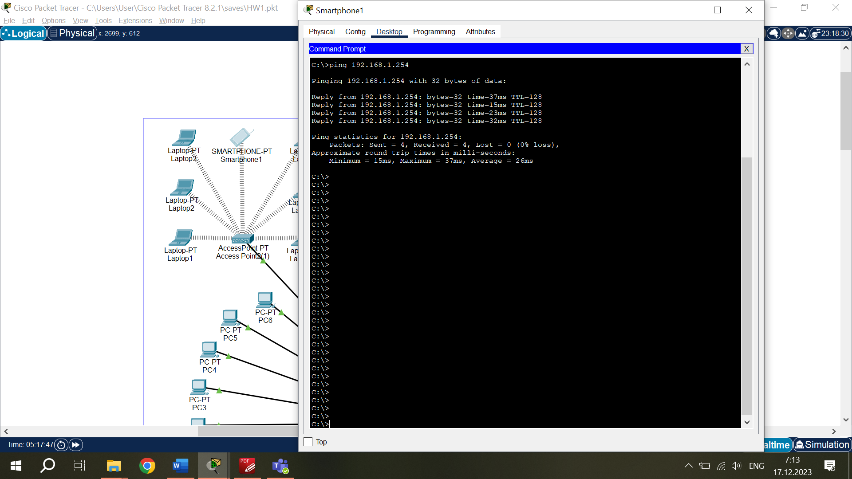

Successful Ping Test inside Working Environment Network. Ping from Smartphone 192.168.1.124 to Local Server 192.168.1.254.

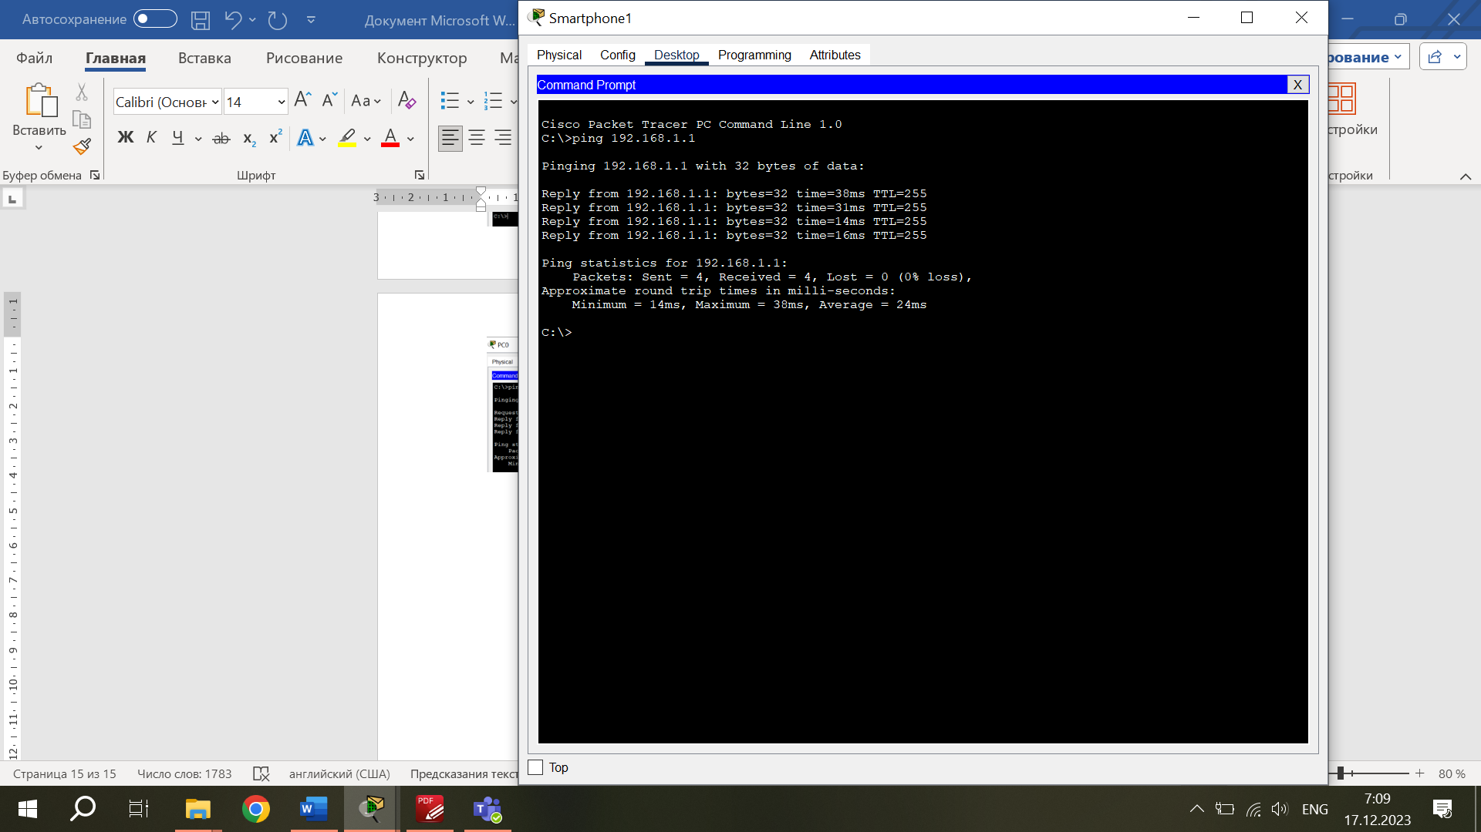

Successful Ping Test from Smartphone in Working Environment Network to Router3. Ping from Smartphone 192.168.1.124 to Router3 192.168.1.1.

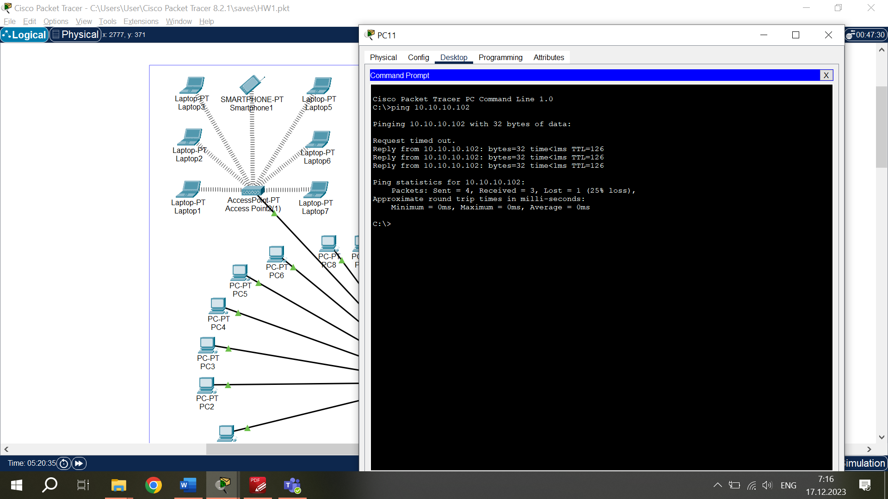

Successful Ping Test from PC in Working Environment Network to WAN PC in DHCP Server Network. Ping from PC 192.168.1.131 to WAN PC 10.10.10.102.

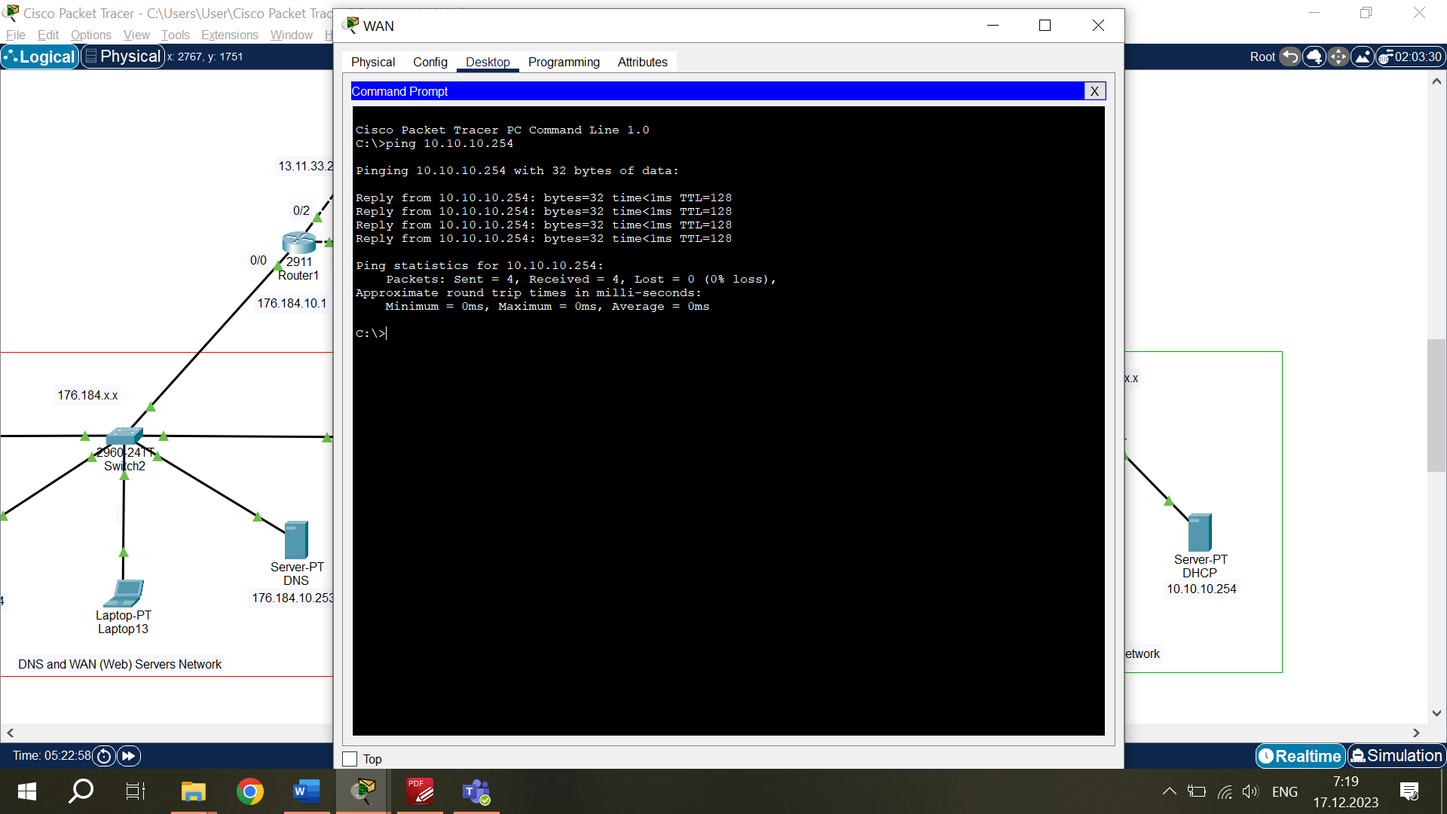

Successful Ping Test inside DHCP Server Network. Ping from WAN PC 10.10.10.102 to DHCP Server 10.10.10.254.

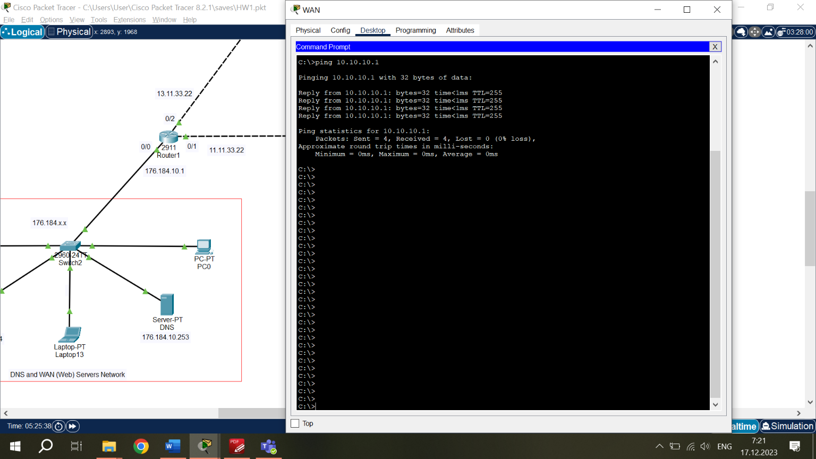

Successful Ping Test from WAN PC 10.10.10.102 in DHCP Server Network to Router2 10.10.10.1.

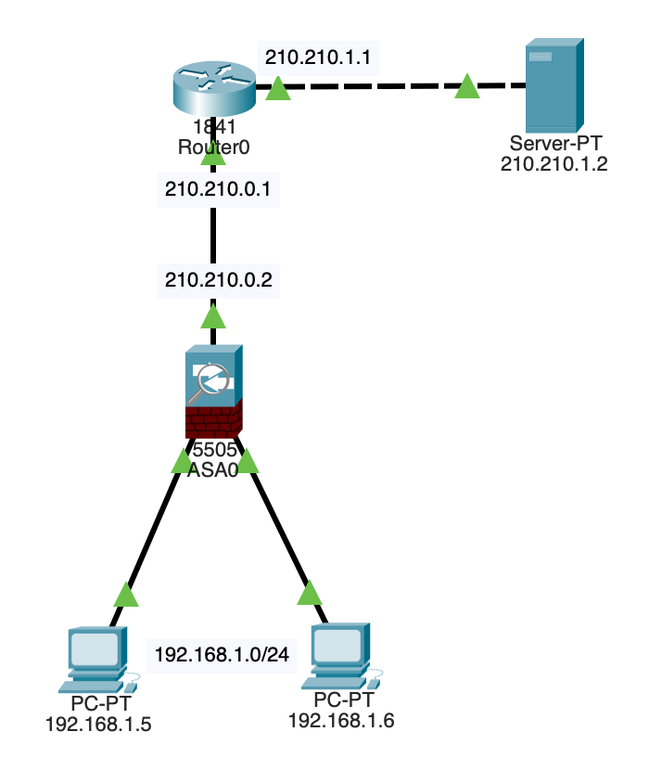

**Configure remote access to the firewall:**

ciscoasa>en

Password:

ciscoasa#conf t

ciscoasa(config)#enable password cisco

ciscoasa(config)#username admin password cisco

ciscoasa(config)#ssh 192.168.1.0 255.255.255.0 inside

ciscoasa(config)#aaa authentication ssh console LOCAL *(user authentication parameters are set)*

**Setting the security level:**

ciscoasa(config)#int vlan 1

ciscoasa(config-if)#security-level 95 *(security level changes)*

ciscoasa(config-if)#end

ciscoasa#conf t

ciscoasa(config)#int vlan 2

ciscoasa(config-if)#ip address 210.210.0.2 255.255.255.252

ciscoasa(config-if)#no shutdown *(restores port operation after it has been switched off or disconnected)*

ciscoasa(config-if)#exit

**Setting the default route:**

ciscoasa(config)#route outside 0.0.0.0 0.0.0.0 210.210.0.1

ciscoasa(config)#end**Setting up the router:**

Router>en

Router#conf t

Router(config)#int fa0/0

Router(config-if)#ip address 210.210.0.1 255.255.255.252

Router(config-if)#no shutdown

Router(config-if)#exit

Router(config)#int fa0/1

Router(config-if)#no shutdown

Router(config-if)#ip address 210.210.1.1 255.255.255.0

Router(config-if)#end

Router#wr mem

Router>en

Router#conf t

Router(config)#ip route 192.168.1.0 255.255.255.0 210.210.0.2

Router(config)#end

Router#wr mem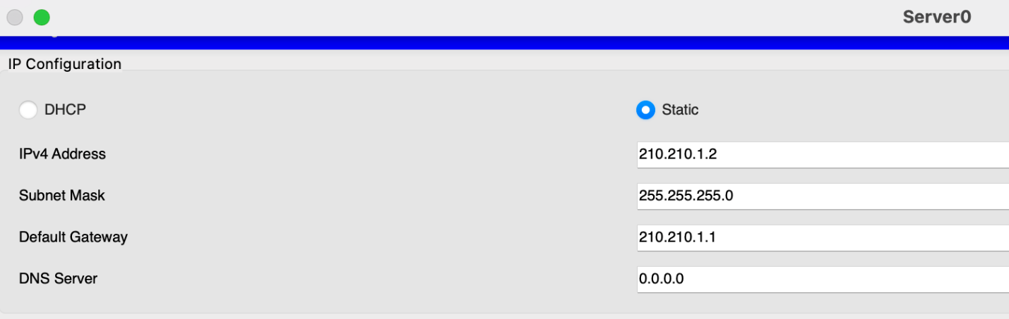

* Initiates a connection from the computer to the router, sends a packet;
* The packet reaches the firewall (ASA0);
* ASA0 processes the information that the packet came from a higher security level than the external interface;
* Writes the session (data) to a dynamic table; and releases the packet;
* The router responds to the ping and sends a counter packet;
* ASA0 inspects this packet and checks it for compliance;
* If all conditions are met, ASA0 passes the packet back to the computer.

**Stateful Inspection Configuration:**

ciscoasa(config)#class-map inspection_default

ciscoasa(config-cmap)#match default-inspection-traffic *(definition of the traffic to be investigated)*

ciscoasa(config-cmap)#exit

ciscoasa(config)#policy-map global_policy

ciscoasa(config-pmap)#class inspection_default *(action definition)*

ciscoasa(config-pmap-c)#inspect icmp *(research protocol)*

ciscoasa(config-pmap-c)#exit

ciscoasa(config)#service-policy global_policy global *(the application of this traffic inspection policy globally)*

ciscoasa(config)#wr mem

**Adding "HTTP" inspection:**

ciscoasa(config)#policy-map global_policy

ciscoasa(config-pmap)#class inspection_default

ciscoasa(config-pmap-c)#inspect http

ciscoasa(config-pmap-c)#end

ciscoasa#wr mem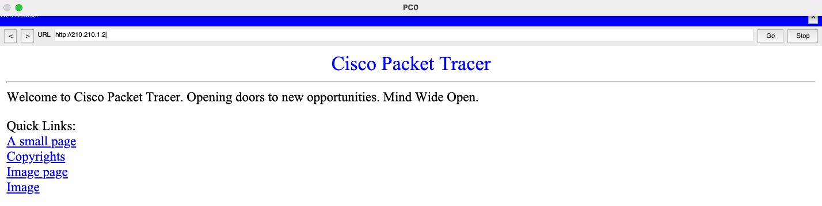

A request from the server cannot reach the computer because the latter has a higher security level: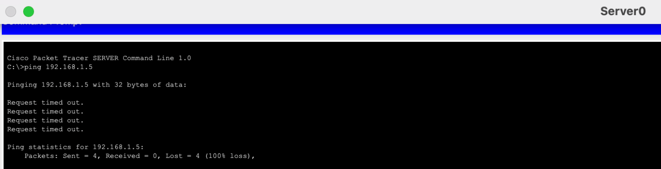

**Removing a ping from a router:**

Router>en

Router#conf t

Router(config)#no ip route 192.168.1.0 255.255.255.0 210.210.0.2

Router(config)#end

Router#wr mem

**Configuring NAT:**

ciscoasa#conf t

ciscoasa(config)#object network FOR-NAT *(by creating objects)*

ciscoasa(config-network-object)#subnet 192.168.1.0 255.255.255.0 *(this object defines the network that will be NATed)*

ciscoasa(config-network-object)#nat (inside,outside) dynamic interface *(the ip address that weighs on the external interface will be used as the address)*

ciscoasa(config-network-object)#end

ciscoasa#wr mem

That is able to see that the NAT setting is used when pinging from the computer to the server:

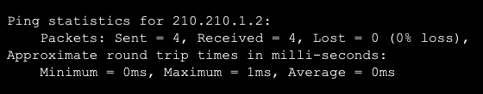

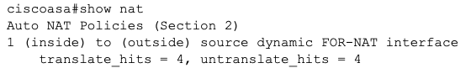

**DMZ (demilitarised zone)** - an area of the corporate network that contains publicly available services such as email server, ftp server, web server, etc.

Publicly available services can be not only services from the local network, but also publicly available services from the external network.

If an attack is made on a public server, the local network remains protected because it is on a different segment.

A DMZ can be organized on the firewall with a "security level".By default, the DMZ has a security level of 50.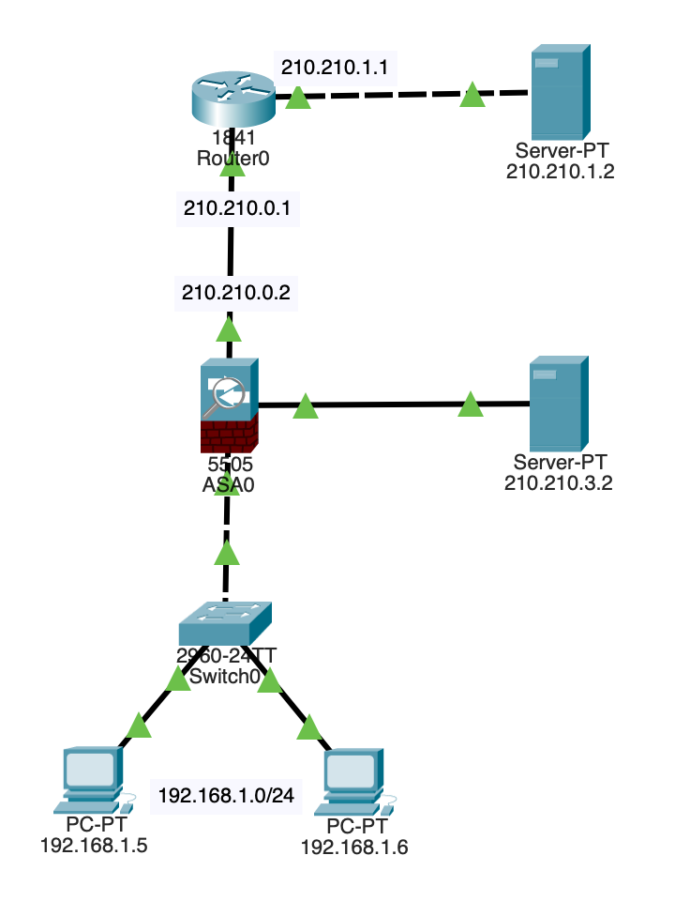

**A route to the network (Server-PT 210.210.3.2) via the external interface (ASA0) is prescribed:**

Router>en

Router#conf t

Router(config)#ip route 210.210.3.0 255.255.255.252 210.210.0.2

Router(config)#end

Router#wr mem

**Configuring ASA0, for which you will need to create another DMZ segment:**

ciscoasa>en

Password:

ciscoasa#conf t

ciscoasa(config)#int eth0/2

ciscoasa(config-if)#switchport access vlan 3 *(new segment is defined)*

ciscoasa(config-if)#exit

ciscoasa(config)#int vlan 3 *(virtual interface is configured)*

ciscoasa(config-if)#nameif dmz

ERROR: This license does not allow configuring more than 2 interfaces with nameif and without a "no forward" command on this interface or on 1 interface(s) with nameif already configured.

*(We get an error because of which we will have to specify an interface on the DMZ-interface where the traffic can flow to)*

ciscoasa(config-if)#no forward interface vlan 1 *(i.e. traffic from DMZ to vlan 1 will be denied)*

ciscoasa(config-if)#nameif dmz

INFO: Security level for "dmz" set to 0 by default.

ciscoasa(config-if)#security-level 50

ciscoasa(config-if)#ip address 210.210.3.1 255.255.255.252

ciscoasa(config-if)#no shutdown

ciscoasa(config-if)#exit

ciscoasa(config)#ping 210.210.3.2 *(check the connection)*

Type escape sequence to abort.

Sending 5, 100-byte ICMP Echos to 210.210.3.2, timeout is 2 seconds:

.!!!!

Success rate is 80 percent (4/5), round-trip min/avg/max = 0/0/0 ms

Checking the connection from the public server to our web server: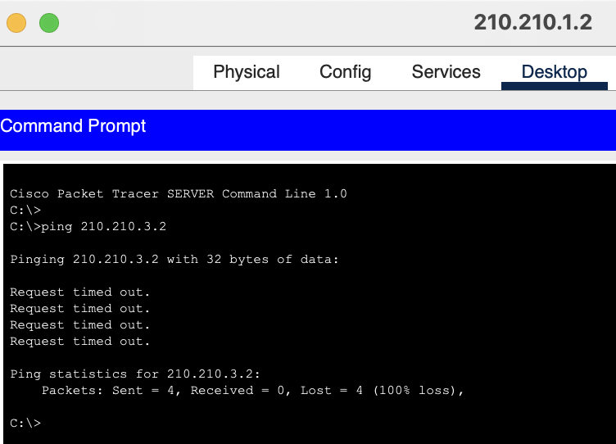As it should be, traffic is prohibited due to security level. The public server has security level 0 and the web server has security level 50.

**To access a certain type of traffic to the DMZ, an "access-list" must be specified:**

ciscoasa(config)#access-list FROM-OUTSIDE extended permit icmp any host 210.210.3.2 *(icmp protocol is allowed from any host to our host)*

ciscoasa(config)#access-list FROM-OUTSIDE extended permit tcp any host 210.210.3.2 eq www *(web traffic is allowed and the port is specified)*

ciscoasa(config)#access-group FROM-OUTSIDE in interface outside *(an access-group is created, the name must be the same as the name of the access-list)*

ciscoasa(config)#end

ciscoasa#wr mem

Checking the connection from the public server to the web server again: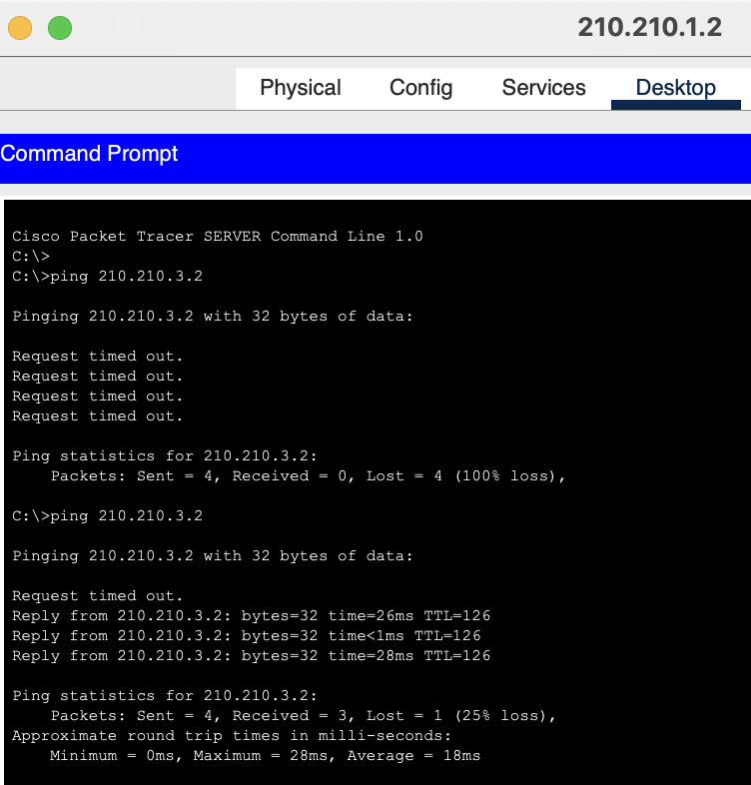

Checking the availability of the web server: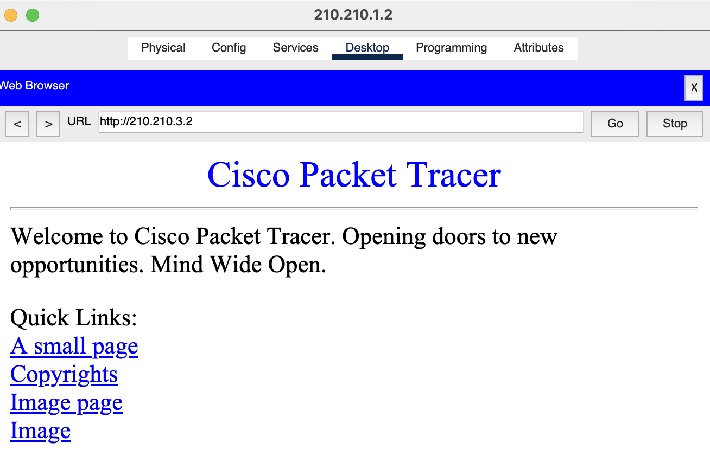

But there will be no access from the local network: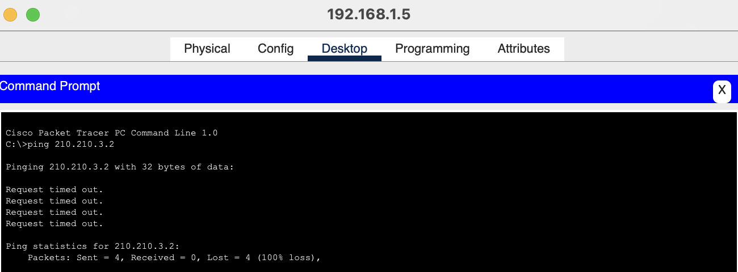

This is because of the "no forward" line that is called with the "show run" command in ASA0. This line restricts the creation of more than two interfaces without using the "no forward" function: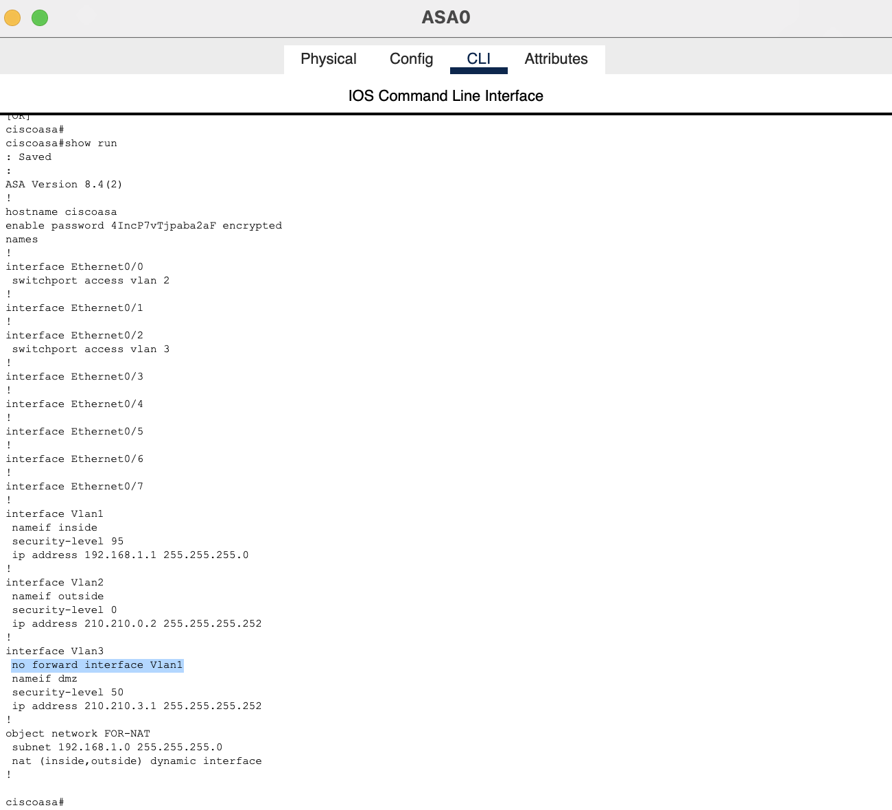

If you have a license, it is possible to remove this line and everything will work afterwards. In this case there is a limitation due to the software.

So DMZ was configured only by specifying security level 50 for the DMZ segment and writing a couple of access-lists on the external interface.

As a result, if to use the knowledge gained and implement it in our previous homework, it is able to get the following network in Cisco Packet Tracer: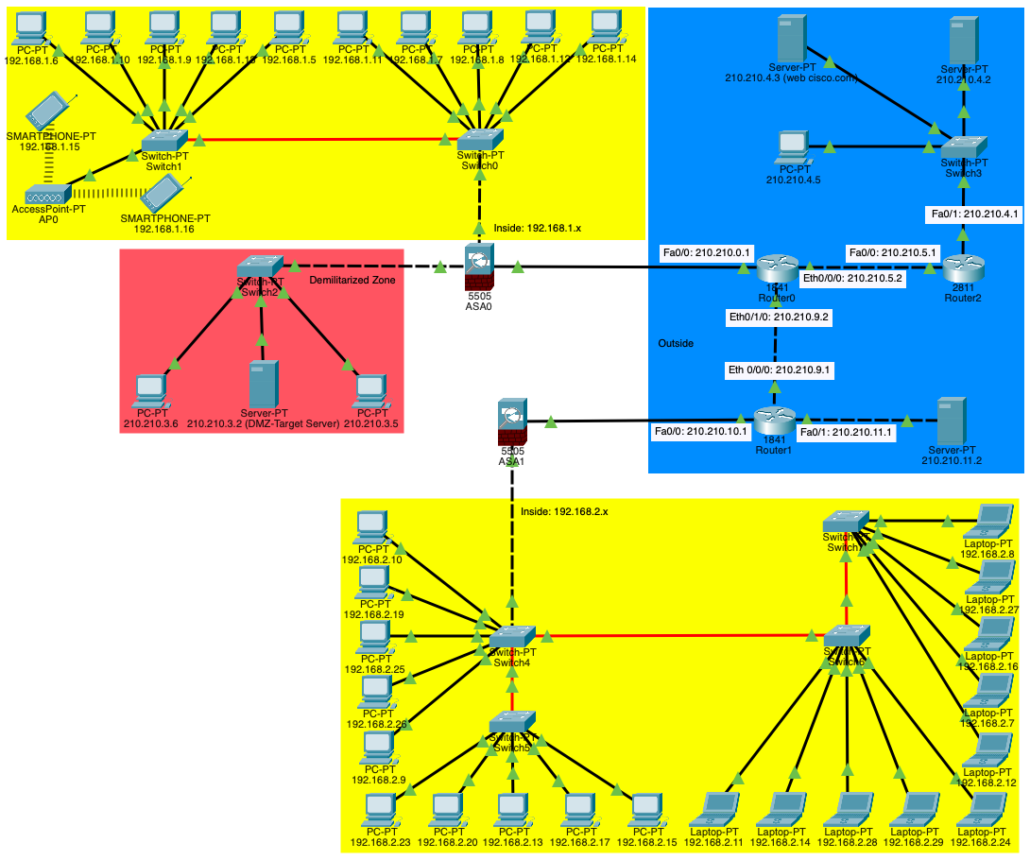

In the image it is able to see the details of the network construction.